Introduction
Density as an intrinsic characteristic of matter can be a difficult concept to grasp. By measuring similar items with slightly different densities, you can begin to understand the relationship of mass and volume in determining density. In this activity you will model data using a linear equation, interpret the slope and intercept values from a linear model and identify a characteristic property of a substance. |  | 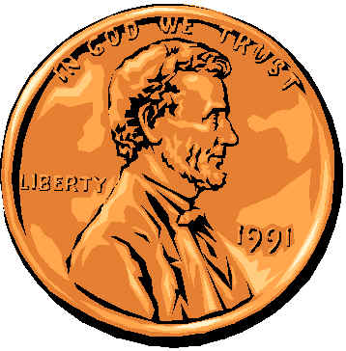
Objectives
- model data using a linear equation
- interpret the slope and intercept values from a linear model
- identify a characteristic property of a substance
What You’ll Need
- TI-84 Plus CE, with Vernier EasyData® App
- Vernier Dual-Range Force Sensor
- Vernier EasyLinkTM,
- 20 pennies dated pre-1982
- 20 pennies dated 1982
- 20 pennies dated post-1982
- paper cup
- string
- pencil
Collecting the Data
- First, you will need to set up your materials:
a) Use a pencil to poke two small holes on opposite sides of the paper cup, near the top rim. Thread a piece of string through the holes, and then tie the ends of the string together to form a loop to hang the cup from.
b) Separate each group of 20 pennies into four stacks of 5 pennies each. As you do this, confirm that you have 20 pre-1982 pennies, 20 pennies from 1982, and 20 post-1982 pennies.
c) Set the range switch on the Dual-Range Force Sensor to ±10 N.
d) Secure the force sensor to the edge of a table. The sensor must be positioned with the hook closest to the ground and should remain level at all times.
- Plug the Dual-Range Force Sensor into EasyLinkTM, and plug EasyLink into the USB port on the calculator. The calculator should automatically turn on and take you to the force sensor’s main screen. | 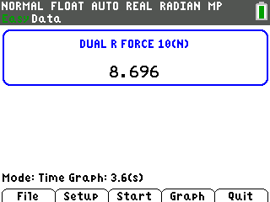
- Plug the Dual-Range Force Sensor into EasyLinkTM, and plug EasyLink into the USB port on the calculator. The calculator should automatically turn on and take you to the force sensor’s main screen.  - Notice that the bottom of your screen says Time Graph. You need to change this to Events With Entry so that you can tell the calculator when to record the force. Press p to select Setup from the main screen. Select option 3: Events with Entry. Your main screen should now say Events with Entry on the bottom. | 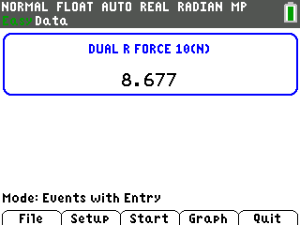
- In this experiment, you are to measure only the weight of the pennies, not including the cup and string. To tell the calculator to ignore the weight of the cup and string, you need to first “zero” the force sensor:  - Hang the empty cup from the hook on the force sensor.  - Press p to select Setup, and select option 7:Zero.  - Wait until the reading is stable and the cup is not moving. Select Zero (not 0) to zero the force sensor. This will set the current weight reading to 0 N, so the sensor will ignore the weight of the cup and the string. | 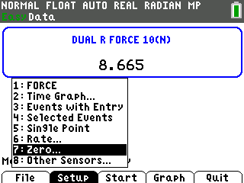
- You are now ready to record the weights of different numbers of pennies:  a) The empty cup should be hanging from the hook on the force sensor. Press q to select Start and begin data collection.  b) When the weight reading of the empty cup is stable (very close to 0), select Keep.  c) The calculator will then ask you to enter a value. Type Ê for the number of pennies now in the cup. Select OK to store this weight-number data pair.  d) Place five of the pre-1982 pennies in the cup, and wait until the reading is stable. Select Keep.  e) Type · as the value for the number of pennies in the cup. Select OK to store this weight-number data pair.  f) Continue with this procedure, using increasing numbers of pennies from before 1982. Each time you keep a data pair, enter the total number of pennies in the cup as the number value.  g) Select Stop when you have finished collecting data for the pre-1982 pennies. | 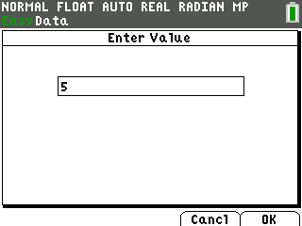
- The calculator screen will now show a graph with number of pennies on the x-axis and weight in newtons on the y-axis. The graph should appear linear (a straight line). If it does not, press r to select Main to return to the main screen, and then repeat steps 4 and 5.
- Determine the equation that describes the relationship between weight and number of pennies:
a) Press q to select Analyz.
b) Select option 2:Linear Fit. This will tell the calculator to compute the equation of the straight line that best fits your data.
c) The calculator will display values for a, b, and R. Record these values in the data table below.
d) The equation of a straight line is y = ax + b. Using the values shown on the screen, write the equation that best fits your data for pre-1982 pennies into the data table. (For example, if a = 3 and b = 5, the equation for the line is y = 3x + 5.)
e) Select OK to plot a line through the data points. Make a quick sketch of this graph next to the information you gathered in the data table.
f) Select Main to return to the main screen.
- Repeat steps 4-7 for the pennies dated 1982.
- Repeat steps 4-7 for the pennies dated after 1982.

Data Table
Penny date | Equation of the best-fit line  (y = ax + b) | Sketch of graph
1963–1981 | a: b: R:  Equation (y = ax + b):
1982 | a: b: R:  Equation y = ax + b):
post-1982 | a: b: R:  Equation (y = ax + b):

Data Analysis
1. The equation for a straight line is y = ax + b, where x and y are coordinates on the line, a is the slope of the line, and b is the y-intercept (the value of y when x = 0). In this case, y is the weight of the pennies, in newtons, x is the number of pennies, and a is the “density” of the pennies. What are the units of “density” in this equation?

2. Explain why the y-intercept, b, should be 0.

3. Was the value of b that you recorded for each group of pennies equal to 0? If not, explain why not.

4. How do the “densities” of the three sets of pennies compare? Based on your measurements, what do you think probably happened to the composition of the penny in 1982?

5. In this activity, “density” is in quotation marks because the slope of the line, a, is not actually density; it is just a measure of density. Explain why the value of a is not really density.

6. Why can you still use slope, a, as a measure of density?

7. What could have made the penny “densities” you calculated inaccurate?

8. R is a measure of how well the line fits the data points. A large value of R indicates that the line is a good fit to the data points. Which group of pennies showed the best fit to a straight line? How do you know?

