Open the TI-Nspire document Say_It_With_A_Survey.tns.  In this activity, you will use bar charts and two-way tables to analyze and summarize categorical data gathered through a short survey. Then, your group will create your own short survey to gather data. You will summarize and analyze your survey results using technology and provide mathematical representations for the rest of the class. | 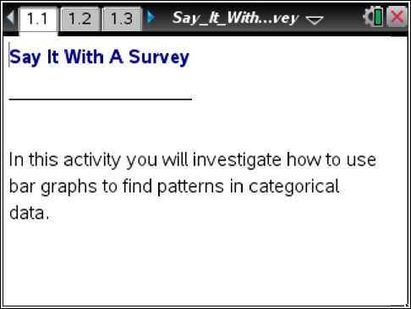

Move to page 1.2.

This TI-Nspire document contains data from 30 middle grades students. The survey asked each student to provide information about their music preference and how many siblings they have. The document also includes information about their television source at home, the telephones used at home, and their gender.
1. What kinds of music do the students surveyed prefer? To find out, you will construct a bar chart to show the music preferences of the survey students. Follow these directions:
- Select the bottom of the page where the horizontal axis should be placed, and select the categorical variable music.
- Select MENU > Plot Type > Bar Chart to change to a bar chart.
- Select the bars to reveal the values.
 Tech Tip: Select > Plot Type > Bar Chart
2. Use the bar chart to complete the table below. How many students favor country, hip-hop, or rock? Explain what you find.

Country | Hip-Hop | Rock | Total

3. Can we find out if there are different music preferences for boys and girls? To do that, construct a split bar chart for music preferences split by gender. Use these directions:
- Select MENU > Plot Properties > Split Categories by Variable.
- Select the variable gender.
- Move your cursor over the bars in the bar chart to see the frequency values and percents.

Tech Tip: Select > Plot Properties > Split Categories by Variable. You may need to back-out to the main Tools menu.

a. What do you notice in the split bar chart?

b. What does this split bar chart tell you that the regular bar chart didn’t show? Explain.

4. a. Use the bar chart to complete the two-way table below.

Music / Gender | Country | Hip-Hop | Rock | Totals
Female
Male
Totals
b. Describe what you find for each preference.

5. Examine the table and bar chart to make relative comparisons of some of the entries. Based on the split bar charts and two-way table:
a. Of those preferring “Country”, how many are males and how many are females? List the values for males and females and then express your answer as a ratio.

b. Of those preferring “Hip-Hop”, how many are males and how many are females? List the values for males and females and then express your answer as a ratio.

c. Of those preferring “Rock”, how many are males and how many are females? List the values for males and females and then express your answer as a ratio.

Move to page 1.3.

6. The survey data include the number of siblings each student has reported. These data will allow us to answer questions related to families of various sizes. You will now construct a bar chart to show the number of siblings reported in the survey:
- Select the bottom of the page where the horizontal axis should be placed, and select the categorical variable siblings.
- Follow this sequence to change the numerical data to categorical: MENU > Plot Properties > Force Categorical X.
- Next, select MENU > Plot Type > Bar Chart to change to a bar chart.
Tech Tip: Select > Plot Properties > Force Categorical X. You may need to back-out to the main Tools menu.

7. a. Use the bar chart to complete the table below.

Zero Siblings | One Sibling | Two Siblings | Three Siblings | Four Siblings | Total

b. Describe the shape of the distribution and the range of data.

8. This survey might provide answers to various questions. For instance, one question might be: Is there a relationship between family size (the number of siblings) and the source for a television signal?
Now you will construct a split bar chart for the number of siblings students have based on the television source:
- Select MENU > Plot Properties > Split Categories by Variable.
- Select the variable tv_source.
- Move your cursor over the bars in the bar chart to see the frequency values and percents.

Tech Tip: Select > Plot Properties > Split Categories by Variable. You may need to back-out to the main Tools menu.
9. a. Use the bar chart to complete the two-way table below.

Siblings / Television Source | Zero Siblings | One Sibling | Two Siblings | Three Siblings | Four Siblings | Totals
Cable
Satellite
Totals
b. What do the split bar chart and the data in the table tell you?

10. Examine the table and bar chart to make relative comparisons using ratios of some of the entries.
a. What patterns stand out in the two-way table or split bar chart? Explain.

- Is there a consistent choice of television source for all family sizes? Explain.

11. Record at least three survey questions you plan to ask in the space below.
1-

2-

3-

12. After your teacher approves your survey questions, your task is to administer the survey and create your own TI-Nspire document with bar charts and split bar charts. Follow these steps:
- Add a new problem to the existing document.
- Enter the responses from your survey into a spreadsheet. Make sure to label each spreadsheet column.
- Add a Data & Statistics pages to display bar graphs and split bar graphs, and then create these charts.
- Record the information from your bar charts into tables on separate sheets of paper for presentation to the rest of the class.
- Describe and analyze what you find in your bar charts and tables in paragraph form.
- Record the information in your split bar charts into two-way tables for presentation.
- Describe and analyze what you find in your split bar charts and two-way tables in paragraph form.
Tech Tip: To add a new problem, select Add >  Problem >  Lists & Spreadsheet.

