Definition
The domain is the set of ____________. The output of a function is called the ____________.

Problem 1 – Cell Phone Situation
Your friend has a cell phone that charges 40 cents per minute. However, he is not allowed to use it for more than 4 minutes.
1. If he talks for 0.5 seconds, how much is the fee?

2. If the cost is a function of time, what is the domain of the cost function?

Press … Í. In list L1, enter numbers for the amount of time that your friend can talk on the costly cell phone.  Move your cursor to the top of list L2. Enter the shown “ceiling” function, 0.4∗–int(–L1/60), to calculate cost.  Note: To enter int(, press », arrow to the NUM menu and select the command. | 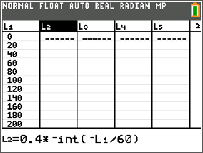
Create a scatter plot of the data. Press y , and select Plot1. Match the settings to those shown at the right.  Press q and select ZoomStat to view the plot.  3. Describe the graph. | 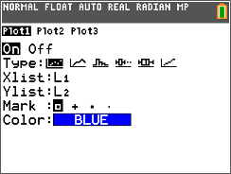
4. What is the range of the cost function?

5. Press r. What is significant about the point just before and after the “step?” Enter some specific values to explore (60 and 61, 120 and 121, and so on).

Turn off Plot1 by pressing y , and selecting PlotsOff.  Press o and next to Y1 enter the ceiling function.  Press s to view the graph. | 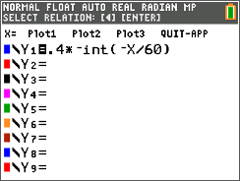
6. Where does each step begin and end? How does this relate to the scatter plot and lists?

7. Which end points are included? Which are not? Draw the graph and indicate where the open circle ends should appear. | 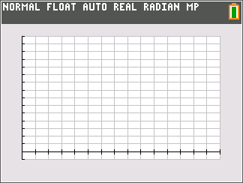
Problem 2 – Snail Mail “Pen Pal”
From April 3, 1988, to February 3, 1991, the U.S. postage rate for first class postage was $0.25 for the first ounce and $0.20 for each additional ounce. The letter must have weighed less than 13 ounces.
8. The cost is a function of the weight. What is the domain of this function? Let x be the input and y be the output.

Graph the function Y1=0.25+0.2∗–int(–(X–1)).  Press r.  9. How much did it cost to mail a 7.25-ounce letter? | 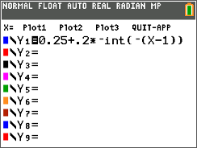
10. This type of function is called a ______ function. What is the range?

Extension/Homework 1 – Shipping
Your friend calls you to tell you about a great sale at an online store for some supplies you need for a school function. You find out that the shipping cost to get your order in 2 days is $11.45 for the first pound and $0.60 more for each additional pound. You can only spend $15 for shipping.
11. What is the domain of the cost function for shipping a package?

12. What is the range for this cost of shipping function? Make a sketch of what the graph would look like.

Extension/Homework 2 – Functions
You can graph the functions to confirm and to deepen your understanding of the solution. What is the domain and range of the following functions?
13. y = x²  15. y =  17. | 14.  16.

