A goodness of fit test tests the hypothesis that observed frequencies in different categories fit a theoretical distribution. The test statistic is .
O: observed frequency of an outcome  E: expected frequency of an outcome | k: number of different categories  n: total number of trials  p: probability for a category  degrees of freedom: k – 1
Problem 1 – The Test Statistic
Press  and set the values equal to the following.  Xmin = –4 Xmax = 20 Xscl = 1  Ymin = –0.1 Ymax = 0.25 Yscl = 1  Then press □ and enterpdf (X, 4) in Y1. The pdf command is found by pressing  . |  | 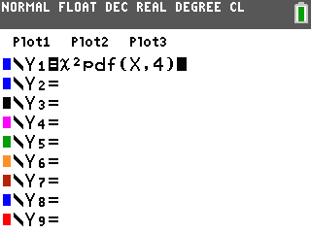
Press . This is the chi-square distribution with 4 degrees of freedom. Study the formula for to answer the following.
1. What would a large value indicate? Why?

2. What would a small value indicate? Why?

3. Would a goodness-of-fit test be left-, right-, or two-tailed? Why?

Problem 2 – Same Proportions Throughout
Number of bus delays in a city in one week:
Mon | Tues | Wed | Thur | Fri | Sat | Sun
46 | 32 | 25 | 23 | 31 | 35 | 40
Test the claim that the bus delays occur in equal proportion on each of the seven days at the 0.05 significance level.
4. Write the null and alternative hypotheses.
5. Find n, the total number of trials (the sum of the delays).
6. What is p, the probability of a delay on any given day, assuming the null hypothesis is correct?
7. Find E, the expected number of delays on a given day, if they occur in equal proportion, given that E = np. Round to three decimal places.

Now that you know E for each day (found in Question 7), and O for each day (in the chart), you will find the value of the test statistic, .  Press  . Enter the observed frequencies in L1. Enter the expected frequency for each day in L2. |  |  | 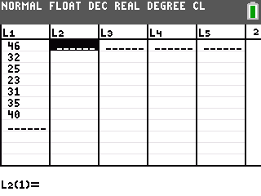
Move the cursor to the top of the third column (over the title of L3) and type the expression for chi-square using L1 for O and L2 for E.  Press . The seven individual quotients are shown in the list. |  |  | 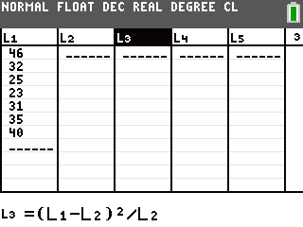
Exit out of the List Editor by pressing  .  Press  . Move to the MATH menu and choose sum(. |  |  | 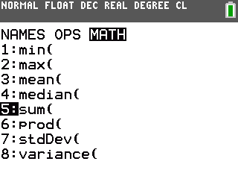
Enter L3, then press . The value shown is the chi-square test statistic.  8. What is the value of the chi-square test statistic?  9. Use a Chi-Square distribution chart to find the critical value for this test. |  |  | 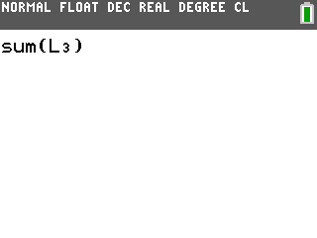
10. Do you reject or fail to reject the null hypothesis? Why?
Press □ and clear the entry for Y1.  The P-value can be found by using the command. It is located in the DRAW menu which is accessed by pressing  . The format is lower bound, upper bound, number of degrees of freedom. Use 1E99 for positive infinity. (E is entered by pressing  .)  11. What is the area to the right of the test statistic?  12. What is the P-value? |  |  | 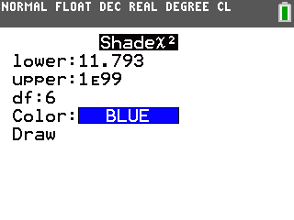
13. Explain how this value confirms your decision to reject or fail to reject the hypothesis.

To check your work, press , choose TESTS, and scroll down to GOF-Test. Keep the default of L1 for the Observed and L2 for the Expected. Update df, the number of degrees of freedom to 6. Press  when the cursor is on Calculate. |  |  | 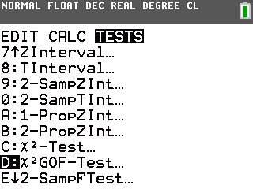

Problem 3 – Different Proportions Throughout
Test if the observed values fit the claimed percents at the 0.05 significance level.
 | Dried Fruit | Nuts | Chocolate | Seeds
Claimed Percent | 35% | 25% | 20% | 20%
Observed values (g) | 119 | 132 | 84 | 115

14. Write the null and alternative hypotheses.

15. What is n, the sum of the observed values?

16. Use the answer to Question 15 and the percents in the chart to find the expected values.
17. Enter the observed values in L1 and the expected values in L2. Create L3 by writing the formula at the top of L3 and using the sum command. What is the test statistic?

18. Use your chart to find the critical value for this test.

19. Do you reject or fail to reject the null hypothesis? Why?

20. Use the command to find the P-value.

Check your work by using theGOF-Test.

