Open the TI-Nspire document Properties_of_Magnetism.tns.  In this activity, you will explore some properties of magnetism by doing the following:  (1) building an electromagnet;  (2) gathering measurements of the electromagnet’s strength; and  (3) analyzing the data. |  | 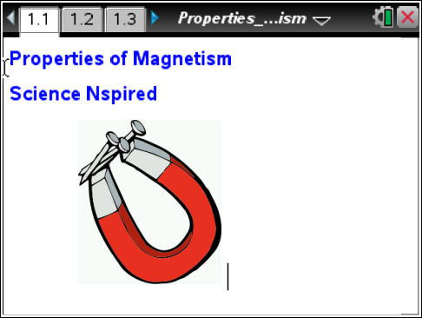
Background  A magnet will attract metal objects to it, but only when the magnet is close enough to do so. If the magnet is too far, the metal objects don’t move. | 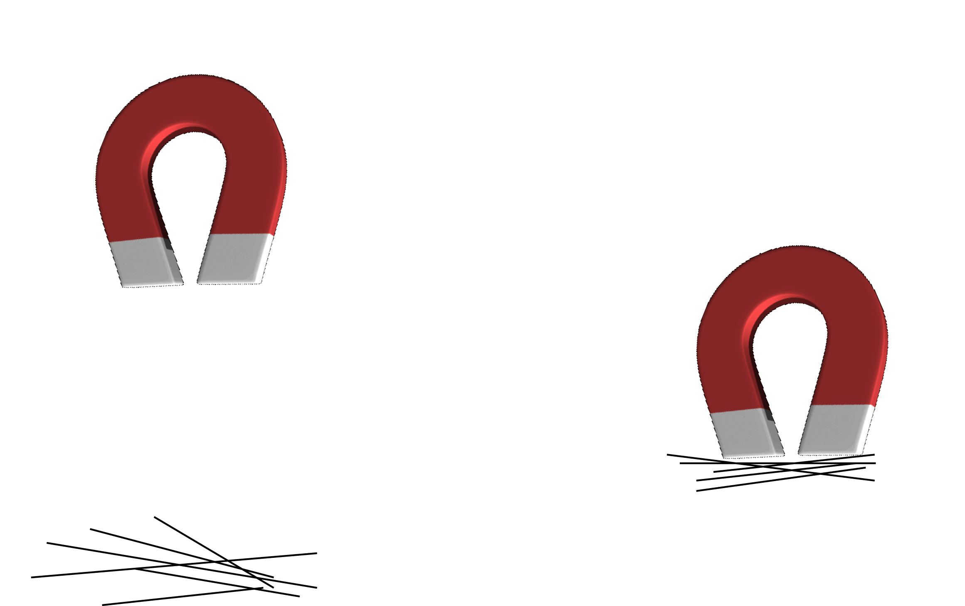
All magnets have a south pole and a north pole. A magnet has a magnetic field around it that goes from one pole to the other. When the metal object is within the magnetic field, then it will be attracted to the magnet.  As you can see, the magnetic field extends beyond the size of the magnet itself. The stronger a magnet, the farther the reach of its magnetic field. | 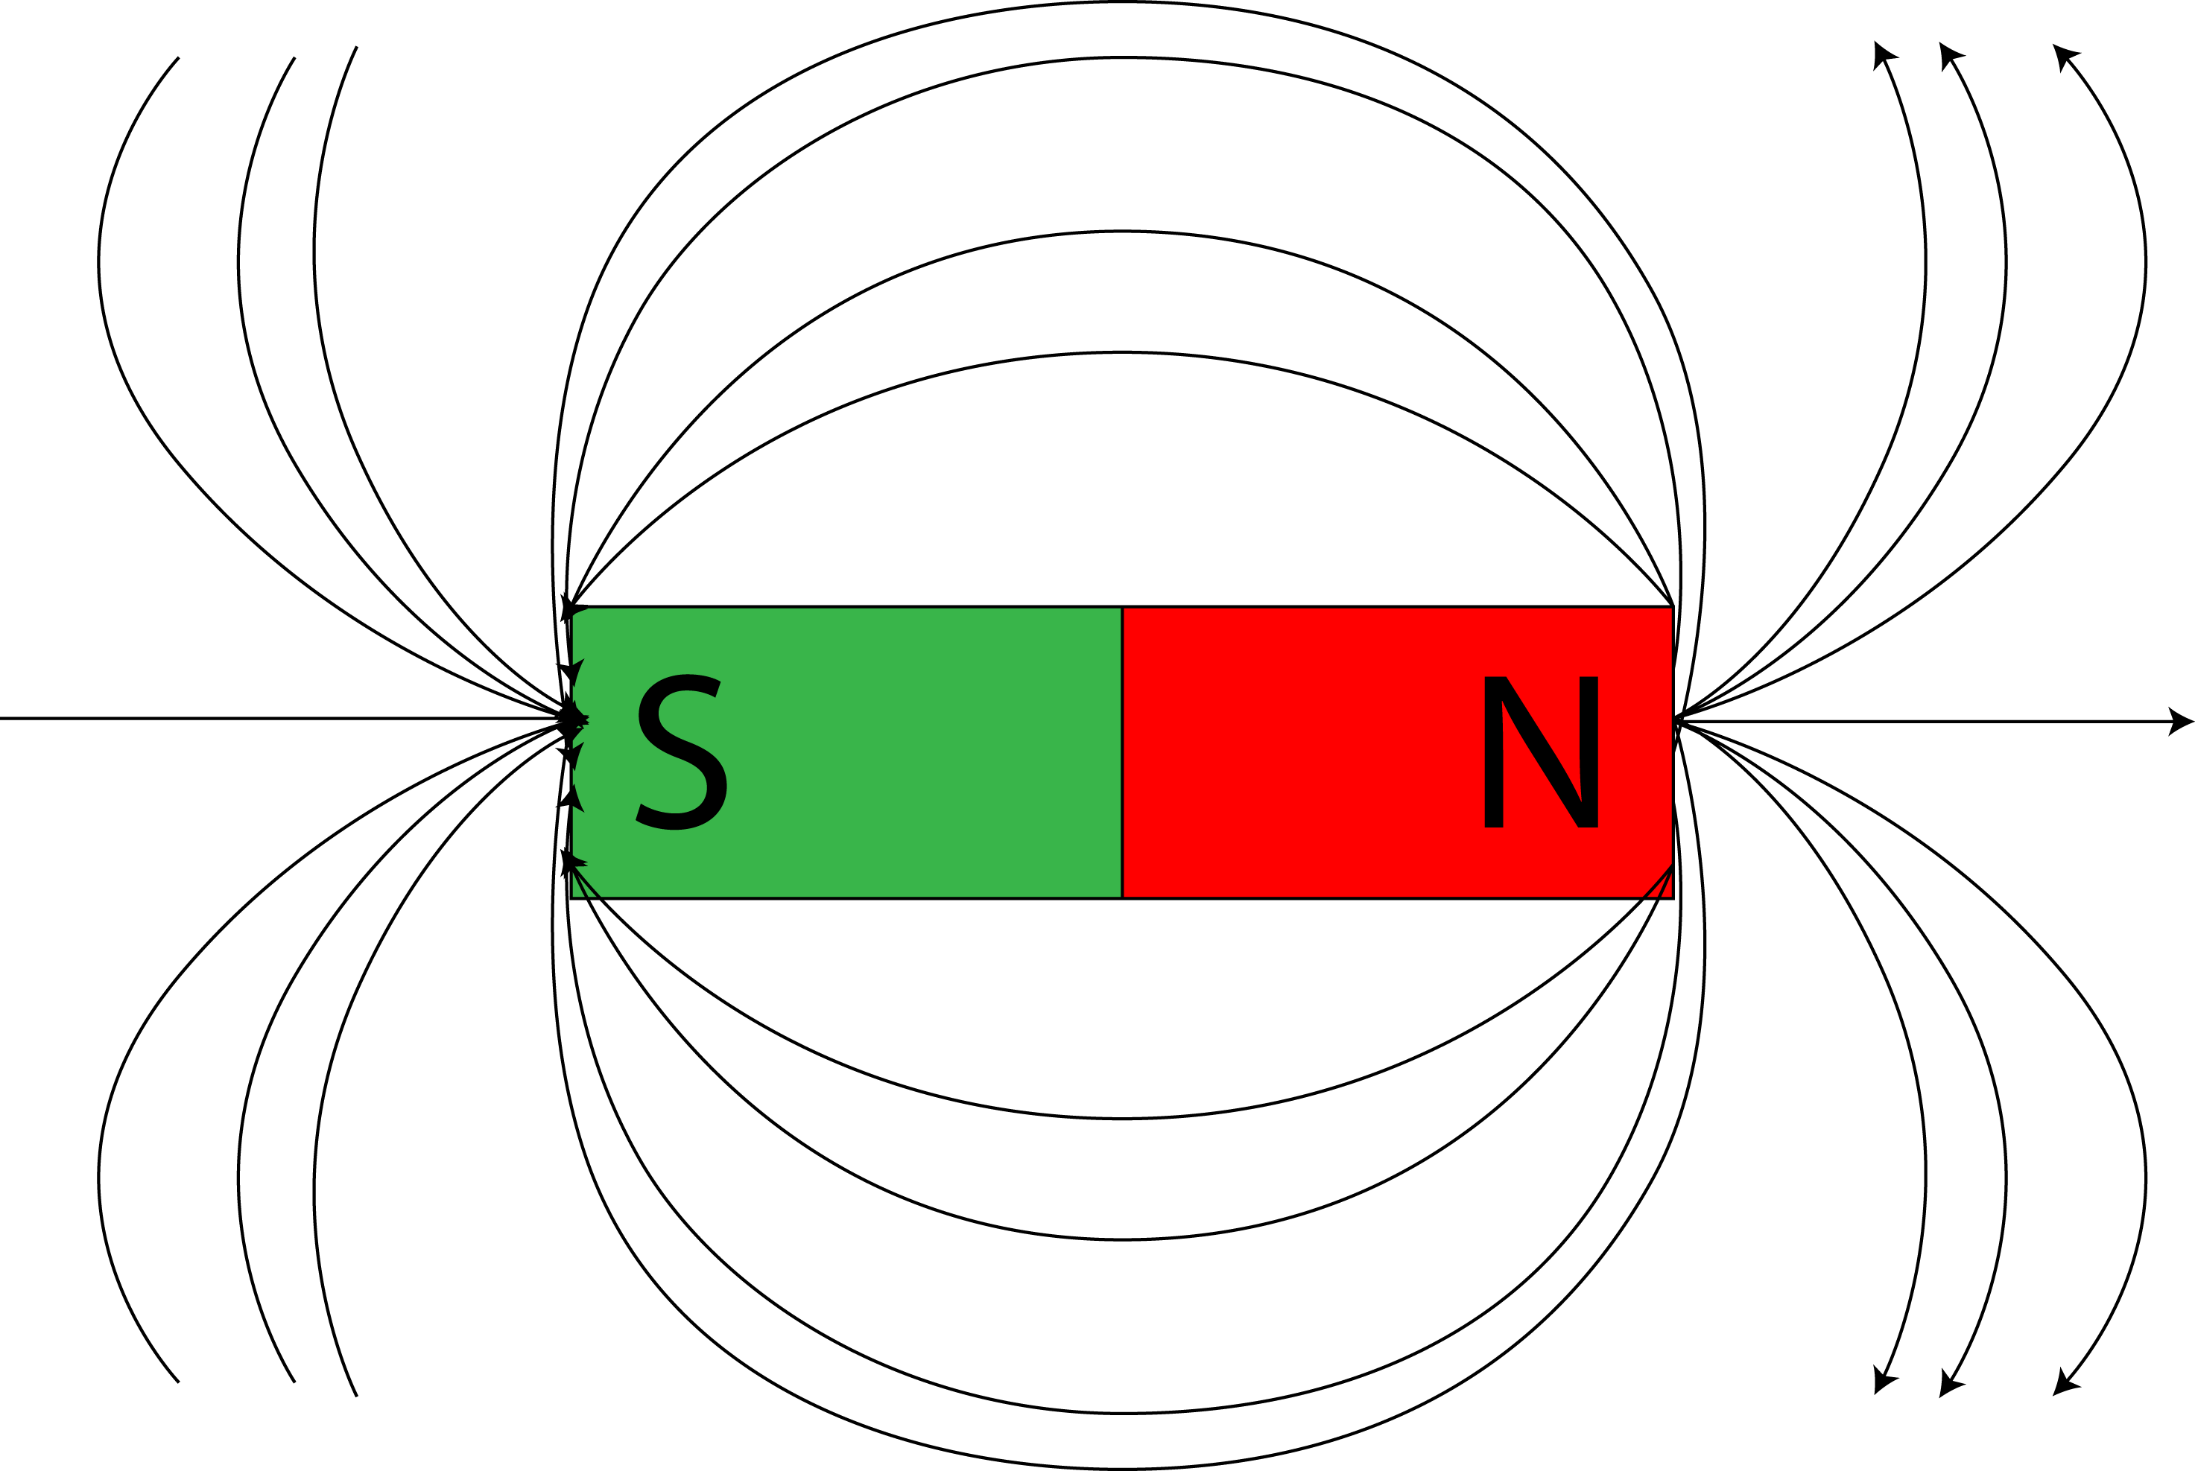
When electricity is flowing through a wire, there is a low-level magnetic field around it, as shown in the diagram at the right. | 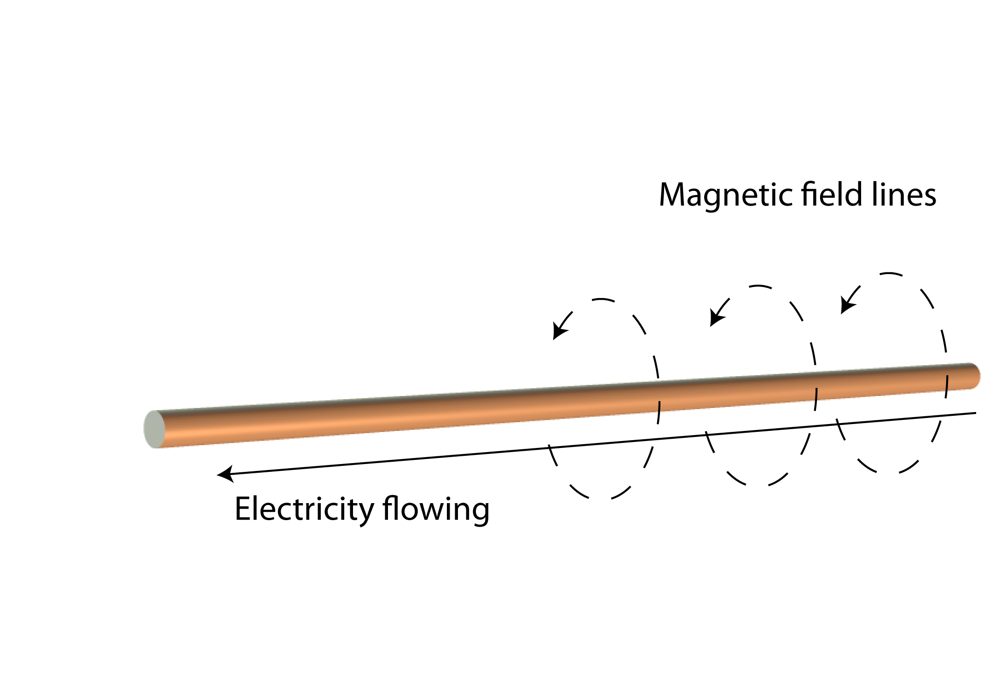
Many naturally occurring metals have magnetic fields. For example, an iron nail has a magnetic field around it. It is also usually a low-level magnetic field. | 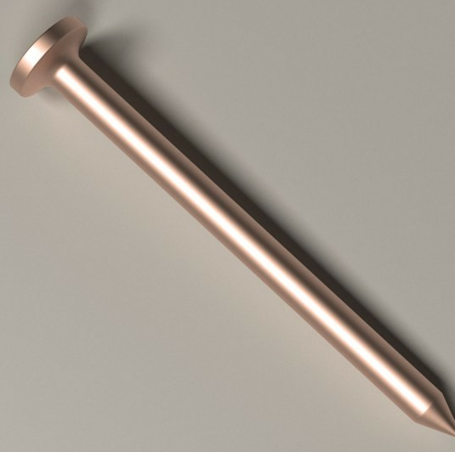
A solenoid combines the previous two ideas by taking a naturally magnetic object and improving the magnetic field by using a coil of wire. Electricity will flow through the coil of wire. The small amounts of magnetism from the individual items are improved by the coiled wire. An electromagnet, a solenoid with an iron or steel core, can be used to create a strong magnetic field.
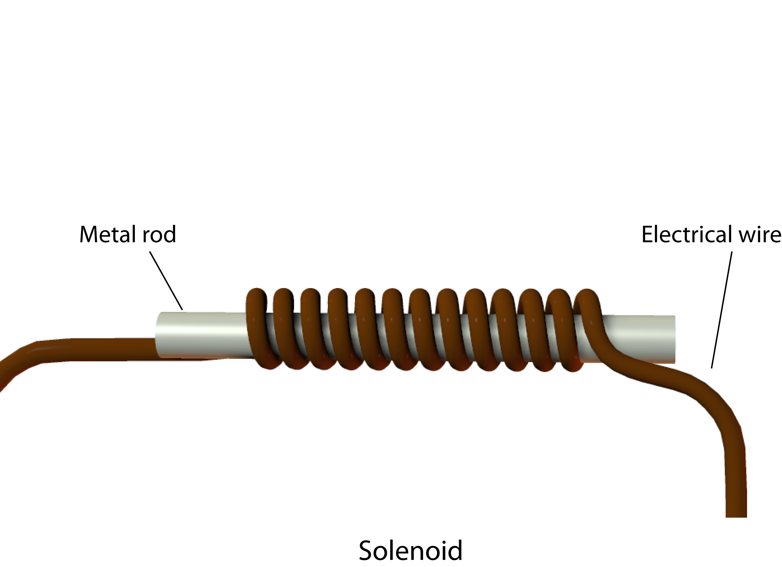

You will now make a solenoid and measure the magnetic field strength of the resulting magnetic field using the TI-Nspire.

Move to pages 1.2 – 1.3.
- Read the information on page 1.2. Then answer question 1 in the tns file and/or on the worksheet.

Although you may not have enough information to fully answer the question, make a prediction based on what you have learned about electromagnets so far. You will be testing your prediction by making a solenoid and measuring its magnetic field strength.

Q1. As the number of turns of wire in an electromagnet increases, the magnetic field around the electromagnet will increase. True or False?

A. True B. False

Explain your answer.

Constructing the Solenoid.
To create your solenoid, make sure you have the following materials available:
- The metal rod for the center of the solenoid
- Electrical wire that you will coil around the metal rod and connect to each end of a battery
- Two fully charged batteries
- Electrical tape, which you can use to secure materials to your workspace
- If you need them, wire strippers, to expose the metal part of the wire
- Paper and pencil

In addition, you’ll need these TI-Nspire components:
- Venier Magnetic Field Sensor (if you’re using the handheld)
- Vernier EasyLink™ or Go!®Link interface (if you’re using a computer)

Your teacher will provide more directions, but be sure to follow these steps to construct the solenoid:
- Tape the two batteries to the work area. Make sure the batteries are connected.
- Make sure the Vernier probe is connected to the computer or handheld. Tape it down to the workspace below the batteries, but clear enough space for the solenoid.
- Loop the wire around the metal bar. Start with 5 loops and keep adding loops of 5 as you gather more data.
- Tape each end of the coiled wire to the opposite ends of the batteries to create an electric circuit.

You are now ready to gather data.

Move to page 1.4.
2. Follow the directions your teacher gives you for gathering data using the Vernier probe.

3. After running the experiment and collecting all of your data, view the graph of the data created by your handheld. End the data collection by closing the collection b ox and disconnecting the interface.

Move to pages 1.6 – 1.8. Answer questions 2 - 4 here and/or in the .tns file.
Q2. Was your answer to question 1 correct? If not, explain the errors in your reasoning.

Q3. Describe the relationship between the number of turns in the electromagnet and the strength of the magnetic field around the electromagnet.

Q4. Explain the shape of the graph.

Move to page 2.1.

4. Read the directions on page 2.1.

Repeat steps 3–10 from problem 1 using the same number of coils, but make the following changes:
- Start wrapping the coils around the middle instead of the end of the core
- Wrap the new coil of top of the previous coil (a stack) instead of along the length of the core

Move to pages 2.3 – 2.4. Answer questions 5 and 6 here and/or in the .tns file.

Q5. Compare the graph for the stacked wire showing field strength vs. number of turns to the graph for progressive wrapping (from problem 1). Explain any differences.

Q6. For the solenoid-type electromagnets listed below, the current is the same and the coiled wire goes the whole length. Which electromagnet would most likely have the strongest magnetic field?

- 5 cm long; 10 turns
- 2 cm long; 6 turns
- 8 cm long; 8 turns

