Open the TI-Nspire™ document Arc_Length_and_Sectors.tns.  An arc is a part or subset of a circle. A sector is a fractional part of a circular region determined by a central angle. In this lesson you will investigate the mathematics of arc length and sectors. | 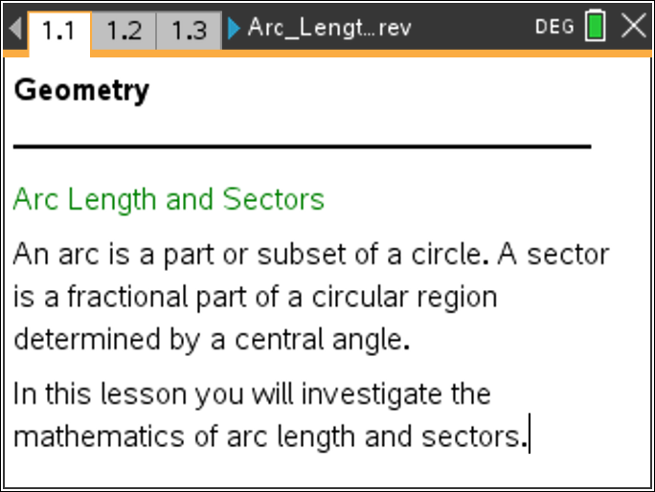

Move to page 1.2.

1. Drag point A around the given circle. What numerical fact do you observe about the measures of the two angles surrounding the center of the circle?

2. What does the measure of a sector angle (or central angle) have to be in order for the sector to be 25% of the circle? 50%? 75%?

Move to page 1.4.

The central angle formed by a sector of a circle is a sector angle.
3. Drag point B around the given circle to test your previous answers. Were you correct?

4. Drag point B until the sector angle is 90°. Compare the ratio of the sector angle measure to 360° with the ratio of the arc length to the circumference. What do you observe?

5. Would your answer to the previous question be different if the sector angle were a different measure?

6. How would you create an arc having a length that is approximately 33.3% of the circumference of the circle? Explain your reasoning.

7. What is the relationship between the length of the arc and the measure of the sector angle that intercepts the arc?

Move to page 2.1.

8. Drag point B around the given circle. How does the measure of the sector angle intercepting an arc relate to the area of its corresponding sector?

9. How would you create a sector whose area is of the area of the circle? Explain your reasoning.

10. What is the relationship between the measure of the sector angle and the area of the sector?

11. Describe in your own words the connection between arc length, area of a sector, and the ratio of the central (sector) angle to the circle.

