Open the TI-Nspire document How_Many_Solutions_2.tns.

Systems of equations can be solved by the graphing method. This activity lets you manipulate one of two graphs to find the number of possible intersections of a system. When a system of linear equations is represented by two lines, you can see how the number of solutions to that system corresponds to the relationship between the lines.

Move to page 1.2.

1. Move the thicker line to show all possible numbers of solutions to the system of equations. Sketch each possibility below.
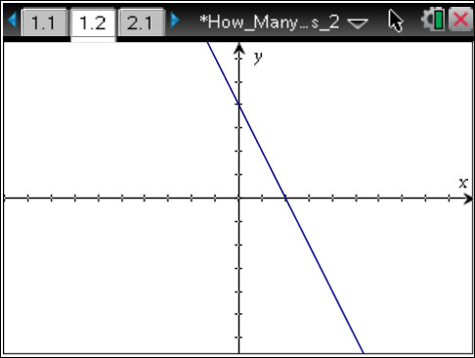

2. Given two lines, at how many points can they intersect?

Move to page 2.1.
3. Move the line to show all possible numbers of solutions to the system of equations. Sketch each possibility below.

4. Given a parabola and a line, at how many points can they intersect?

Move to page 3.1.
5. Move the line to show all possible numbers of solutions to the system of equations. Sketch each possibility below.

6. Given a circle and a line, at how many points can they intersect?

Move to page 4.1.
7. Move the line to show all possible numbers of solutions to the system of equations. Sketch each possibility below.

8. Given a cubic and a line, at how many points can they intersect?

9. A real root exists at the point where a graph intersects the x-axis.
a. On page 1.2, rotate the thicker line until it appears to be horizontal. Consider this line to be a moveable x-axis. Translate the line up and down to determine the possible numbers of real roots. How many possible real roots exist?

b. Repeat this process for page 2.1. How many possible real roots exist?

c. Repeat this process for page 3.1. How many possible real roots exist?

d. Repeat this process for page 4.1. How many possible real roots exist?
10. How do the answers in question 9 relate to the answers in questions 1–8?

11. The vertical line test is used to determine whether a relation is a function. If a vertical line passes through more than one point on the graph of a relation, the relation is not a function.
a. On page 1.2, rotate the thicker line until it appears to be vertical, and then translate it from left to right across the screen. Is the graph a function? Explain.

b. Repeat this process for page 2.1. Is the graph a function? Explain.

c. Repeat this process for page 3.1. Is the graph a function? Explain.

d. Repeat this process for page 4.1. Is the graph a function? Explain.

Move to page 5.1.
12. Drag the point to move the circle to show all possible numbers of solutions to the system of equations. Sketch each possibility below. (It is possible to change the diameter of the circle.) Use one screen to show more than one answer if necessary.

13. Given the following systems, determine all possible numbers of solutions:
a. the graphs of a circle and a parabola

b. the graphs of two circles

c. the graphs of two parabolas where one parabola is sideways and the other opens up

