Open or create the TI-Nspire document Triangle_Sum_Theorem.tns.  In this activity, you will make a conjecture about the sum of the measures of the interior angles of a triangle and prove the Triangle Sum Theorem. | 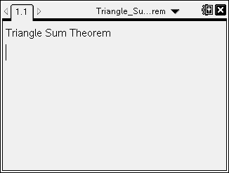

Move to page 1.2. | Press / ¢ and / ¡ to navigate through the lesson.
1. a. What happens when you click the Δ and the ∇ on the slider?

b. Grab and move point B. What do you notice?

c. What do you observe about the sum of the angles in the triangle?

Use the slider to change the measure of to 90°.
2. a. What do you observe about the measures of and ?

b. Change the measure of to 30°. Make a prediction about the measures of and .

3. a. If the measure of is 180°, make a conjecture about the measures of and . Explain your reasoning.

b. Use the slider to change the measure of to 180°. Justify your conjecture.

Move to page 1.3.

On page 1.3, was constructed so that . Use the slider to change the measure of .
4. Which angles are always congruent and why?

5. Describe the relationship among the three angles associated with vertex B.

The Triangle Sum Theorem states that the sum of the measures of the interior angles of a triangle is 180°.

6. Use your reasoning in questions 4 and 5 to prove the Triangle Sum Theorem.

