Problem 1 – A Frayer Square for prime
A square divided into four sections is given below. Write information that you know about prime numbers in each section. Use words and numbers. Add more than one piece of information to a section if you know a lot about it!
Definition: | Fun facts:
- a number greater than 1 that... | - 2 is the only even prime.
Examples | Non-examples
- 2, 3, … | - –7, 0, …
Problem 2 – Exploring a factor tree for a composite number
Have you ever made a factor tree for a number? If so, then you already know what the prime numbers are. You may or may not know how to write the prime factorization using exponents rather than repeated multiplication. We will explore this skill using the TI-84 calculator together.
Here is a factor tree for the composite number 24.  Its prime factorization is 24 = 2⋅ 2 ⋅ 2 ⋅ 3 or 24 = 2³ ⋅ 3.  - Why is 3 the exponent for the factor 2? |  | 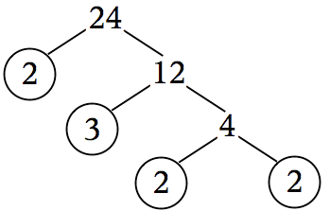
- Is 24 a prime number? Explain.

Problem 3 – Exploring division as a means to finding prime factors
You can use also division to find the prime factors of a number. Follow the steps to find the prime factorization of 30.
Think of a number that divides 30 evenly, like 3. Divide 30 by 3. | 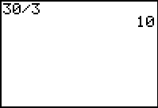
Draw a factor tree. Circle any factors that are prime (those cannot be divided further). | 30  10  3
Think of a number that divides 10 evenly, like 2. Divide 10 by 2. | 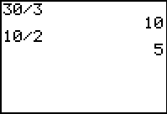
Expand the factor tree. Circle any factors that are prime. When none of the factors can be divided further, you have found the prime factorization. In this case, 30 = 2 ⋅ 3 ⋅ 5.  - Why does the factorization of the number 30 NOT have any exponents? | 30  10  3  2  5
Use division to find the prime factorization of 36. Write your answer in exponent form. Show your work as a factor tree.
36 = _____________

Problem 4 – Factoring on your own
Use the methods above to find the prime factorization of each number. Show your work as a factor tree and write the factorization in exponent form.
1. 27 = _____________ | 2. 56 = _____________ | 3. 72 = _____________

