Activity Overview:  Similar triangles will be created using dilation to investigate the relationship between scale factor and area and perimeter.  Materials  - Technology needed (TI-Nspire™ handheld, computer software) | 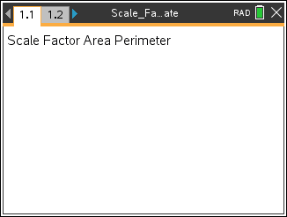

Steps
Step 1: Preparing the document
- Open a new document by clicking c > New Document > Add Notes.
- Type: Scale Factor Area Perimeter.

Note: To obtain capital letters, press the g key, then the letter.

- Press ~ > File > Save As ….
Type: Scale_Factor_Area_Perimeter.
Tab to ¾ and press ·.

Note: To obtain the underscore, press / _.

4. Add a new page by pressing / ~ > Add Geometry.
5. To hide the scale in the right corner of the screen, go to Menu > View > Hide Scale.

Step 2: Drawing triangle ABC and labeling its vertices  1. Press Menu >Shapes > Triangle.  Note: Draw a small triangle because you will make it twice as large.  2. Move the cursor to a position near the top of the screen to place the first vertex. Press ·. Immediately press g A.  3. Move the cursor to a new location for the second vertex and press ·. Immediately press g B.  4. Move the cursor to a new location for the second vertex and press ·. Immediately press g C.  5. Press d to exit the Triangle tool. | 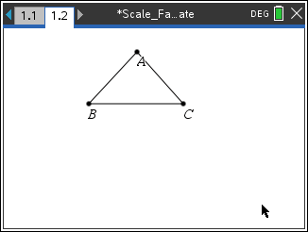
Step 3: Defining the scale factor as 2 for the dilation  1. Press Menu > Actions > Text.  2. Move the cursor to where you would like to put the text. Press ·.  3. Type the number 2. Press ·.  4. Press d to exit the Text tool. | 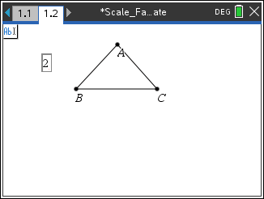
Step 4 Dilating the triangle  1. Press Menu > Transformation > Dilation.  2. Move the cursor to vertex A of the triangle (center of dilation). When the words point A appear, press · or x.  3. Move the cursor to the number 2 (scale factor). When the word number appears, press · or x.  4. Move the cursor to the triangle. When the words triangle ABC appear, press · or x.  5. Press d to exit the Dilation tool. | 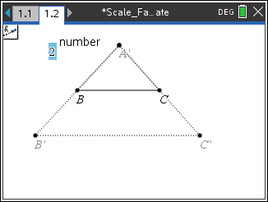
Note: If you cannot see the entire figure, drag the vertices or sides of the original triangle until you can. Point A, the point selected as the point of dilation, cannot be dragged, but the other two vertices of the triangle and the triangle itself can be. | 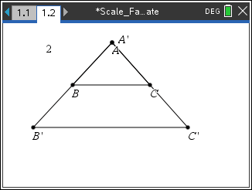
If Needed  Step 5: Labeling the new points – if not automatically labeled.  1. Press Menu > Actions > Text.  2. Move to the point on the new triangle that is the image of point B. The word point will appear. Press ·. Type g B º ' (apostrophe, see figure at right) and press ·.  3. Move the cursor to the image of point C. The word point will appear. Press · g C º ' and press ·.  4. Press d to exit the Text tool. | 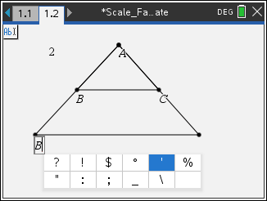
Step 6: Measuring and displaying the perimeter of the triangles  1. Press Menu > Measurement > Length.  2. Move the cursor over of ΔABC until the outline of ΔABC is bold and press ·.  3. Move the displayed measurement near the bottom of the screen and press · to release it. (This is the perimeter of ΔABC.)  4. Move the cursor over of ΔAB'C' until its outline is bold and press ·.  5. Move the measurement beside the previous measurement. Press ·. (This is the perimeter of ΔAB'C'.)  6. Press d to exit the Measurement tool. | 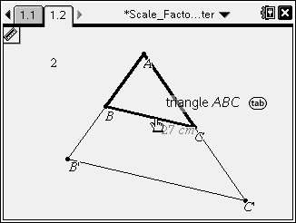  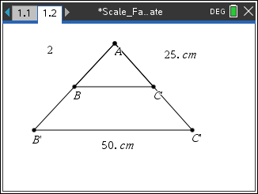
Step 7: Measuring and displaying the area of the triangles  1. Press Menu > Measurement > Area.  2. Move the cursor over of ΔABC until the outline of ΔABC is bold and press ·.  3. Move the measurement below the perimeter measurement for ΔABC and press ·.  4. Repeat for ΔAB'C'.  5. Press d to exit the Measurement tool. | 