How Many Solutions?  ID: 9283 | Time required  60 minutes

Activity Overview
In this activity, students graph systems of linear functions to determine the number of solutions. Once acquainted with each of the three possibilities—one solution, zero solutions and infinitely many solutions—they use their experience with the graphs to investigate the relationship between the coefficients of a pair of linear equations and the number of solutions. In the investigation, students are given one line and challenged to draw a second line that creates a system with a particular number of solutions. By repeating this experiment and recording the equations of the line, students gather data that they use to write rules about the number of solutions of a linear system based on its coefficients.
Topic: Linear Systems
- Graph a system of linear equations to determine whether they have no solutions, one or infinitely many.
- Examine the coefficients of a pair of linear equations to determine how many solutions for the system.

Teacher Preparation and Notes
  - This activity is appropriate for students in Algebra 1. It is assumed that students are familiar with linear functions, their graphs, and have solved linear systems algebraically.
- This activity is designed to have students explore individually and in pairs. However, an alternate approach would be to use the activity in a whole-class format. By using the computer software and the questions found on the student worksheet, you can lead an interactive class discussion on the slope of perpendicular lines.
  - This activity uses the Cabri Jr. application. Ensure that this application and the four files are loaded onto the graphing calculator before beginning the activity.
- To download the Cabri Jr. files and student worksheet, go to education.ti.com/exchange and enter “9283” in the keyword search box.

Associated Materials
- HowManySolutions_Student.doc
- HOWMANY1, HOWMANY2, HOWMANY3, HOWMANY4 (Cabri Jr. files)

Suggested Related Activities
To download any activity listed, go to education.ti.com/exchange and enter the number in the keyword search box.
- Math Man on the Slopes (TI-84 Plus family) — 11748
- Exploring Linear Equations (TI-84 Plus family) — 8189
- Perpendicular Slopes (TI-84 Plus family) — 5734

Problem 1 – Graphing systems of linear equations
In the first problem of the activity, students will graph the three systems given on the worksheet. They should enter them into the Y= screen and then view the graph in the ZStandard view.  For each system students need to sketch the graph on the worksheet and record the number of solutions or intersection points. |  | 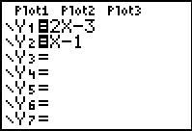
After students graph the systems, they will make conjectures. Discuss the answers with students as a class.
If the two lines…  - Cross at a single point  - Never cross (are parallel)  - Are really the same line | Then the system has…  - 1 solution  - no solutions  - infinitely many solutions

Problem 2 – Create your own system
In the second problem of the activity, students open the Cabri Jr files one at a time. Each file contains 1 line already drawn. Students are to draw a line for each scenario, 1 solution, no solutions, and infinitely many solutions. They need to record the equation of their line in the appropriate place in the table on the worksheet.  Students can use the Line tool (F2 or ) to place a line on the graph and use the Coord. & Eq. tool (F5 or ) to find the equations of the lines. | 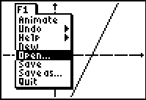
After students complete the table, they will answer questions 4–8 based on the graphs they drew. Discuss the answers to question 8 as a class. They should realize the following rules:
- A linear system has no solution if the equations have the same slopes and different y-intercepts.
- A linear system has infinitely many solutions if the equations have the same slopes and the same y-intercepts.
- A linear system has one solution if the equations have different slopes and different or the same y-intercepts.
Students are given a couple of linear systems at the end of the activity to apply what they have learned about linear systems. They should determine how many solutions each system has without graphing. Then they can check to see if they are correct by graphing.

Solutions
1. 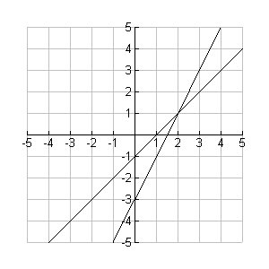  one solution | 2. 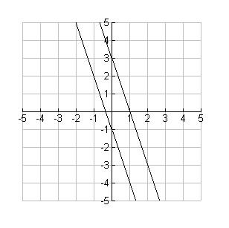no solutions | 3. 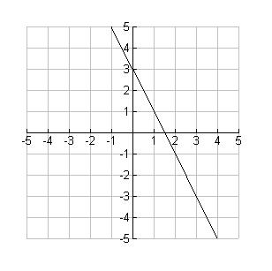infinitely many solutions
4. The equations that form systems with no solutions or infinitely many solutions have the same slope.
5. The equations that form systems with infinitely many solutions have the same
y-intercept.
6. The equations that form systems with infinitely many solutions are equivalent.
7. Sometimes equations are written differently although they equivalent. One equation may have been multiplied by a constant on both sides or terms moved around. For example, $\left\{\begin{matrix}4x+2y=6 \\ y\text{=-}2x+3\end{matrix}\right.$.
8. A linear system has no solution if both equations have the same slope but different y-intercepts.
A linear system has infinitely many solutions if both equations have the same slope and same y-intercepts.
A linear system has one solution if the two equations have different slopes and different or same y-intercepts.
9. one solution
10. infinitely many solutions
11. one solution
12. no solution

