Consider the right triangle ABC with hypotenuse 17.3 units and one-leg 14.7 units. Use the sine ratio to determine the measure of angle A. | A  17.3  14.7  C  B
Press , highlight DEGREE and press .  Press □. Enter the equation y = sin(x) in Y1 and the ratio of leg opposite to hypotenuse in Y2.  This will allow you to examine the table and the graph to determine what value of x (what degree measure) satisfies both. | 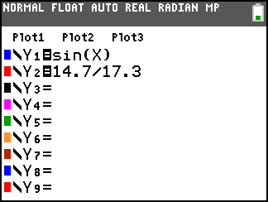
Press . Set the window as shown. The Xmin and Xmax reflect that the period for the sine function is 360°. The function is never below –1 or above 1, so set Ymin and Ymax accordingly. | 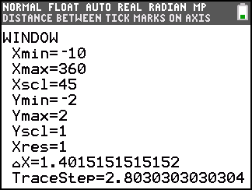
Press .
- What do you notice about the two graphs?

- How many x-values satisfy both equations?

- What does this mean about ∠A?

Press . Press  to trace on Y2. This allows you to see that the ratio 14.7/17.3 is about 0.8497.
Press  to trace on Y1. Move to the right-most intersection point.
- What does the x-value appear to be, rounded to the nearest whole number?

- What does this tell about ∠A?

Move to the left-most intersection point. It appears to be about 57°.
- What does this tell about ∠A?

- Which measure, 124° or 57°, is going to be the measurement of ∠A? Why?

To get a more exact estimate, examine the table in smaller increments. Press   and set TblStart and ΔTbl (change in table) as shown. This will zoom in on the area surrounding the estimated point of intersection.  - At what x-coordinate do the two functions seem to be the closest in y-value? | 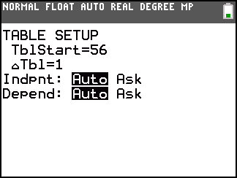
To calculate the exactly intersection, press . Press   to access the Calculate menu. Select 5: intersect.  - The question “First curve?” will appear on the screen, asking you to identify one of the two functions you want to find the intersection of. Press . | 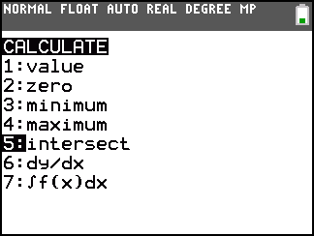
- The question “Second curve?” will appear on the screen, and the cursor will have hopped to the other function, asking you to identify the other of the two functions you want to find the intersection of. Press . [*NOTE: if there were more than two curves graphed, this feature would allow you to find the intersection of any two.]
- The question “Guess?” will appear on the screen, asking you to move close to the intersection that you want calculated. In this instance there are two, but only one satisfies the question about the measure of ∠A. Move close to it and press .
- The point of intersection will be provided.
Another method for solving this problem would be to return to the Home screen. Press   to access the inverse sine command. Enter the ratio 14.7/17.3 and press .  Explore using these methods with other right triangle problems. | 