It’s A Rat Race For The Zeros  ID: 11688 | Time required  15 minutes

Activity Overview
In this introductory activity, students will use a program and graphing to help them explore the Rational Root Theorem. They will compare sets of functions that have at least one real zero or have no real roots and then determine how the factors of the leading coefficient and the constant can produce a zero.

Topic: Polynomial Functions
- Zeros
- Rational Root Theorem

Teacher Preparation and Notes
- Students will need guidance in exploring the activity.
- To download the student worksheet and calculator file, go to education.ti.com/exchange and enter “11688” in the quick search box.

Associated Materials
- PrecalcWeek17_RatRace_worksheet_TI84.doc
- RATRACE program

Suggested Related Activities
To download any activity listed, go to education.ti.com/exchange and enter the number in the quick search box.
- Watch Your P’s and Q’s (TI-84 Plus family) — 8975
- Watch Your P’s and Q’s (TI-Nspire technology) — 8517

Part 1 – Graphing to find zeros
Students are given two sets of functions. They are to graph the functions one at a time and find the zeros using the method outlined in the activity.  For the first function, students will need to zoom in to see the graph near the x-axis. Near the x-value of –1, there are actually two zeros even though it looks like there is only one in ZStandard view.  Students should see that the graphs of the first set of functions have at least one real zero and the graphs of the second set of functions do not have any real zeros.  For easy reference in the second part of the activity, students should enter the functions in Y1 through Y6, pressing enter on the = sign to select or deselect a graph. | 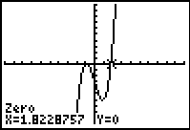  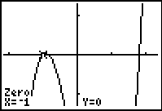
Part 2 – Exploring Rational Root Theorem
In the second part of this activity, students will use a program called RATRACE that returns a list of all the factors of the number inputted. The students will use this to produce factor-sets for the leading coefficient as well as constant term of the given function.  For any of the lists that go off the screen, students can press    to view the list in list L1. It may be beneficial for students to write down the lists on the worksheet as they work through each function.  Students are to determine what combination of the values in the sets, if any, will produce a zero (or a root). Explain to students that they can use all the operators, + – × /, on one number from the first set and one number from the second set. The end result is to find the one formula that works to find all (rational) zeros.  To do this exploration, remind students that they found the zeros when they had earlier graphed the functions. This will give them a starting point. | 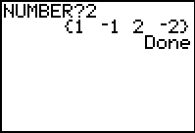  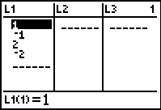  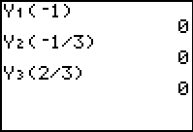
Students will need to work through all three functions in the first table. After determining that it was possible to find at least one zero for each of these functions, they will investigate the next table of three functions. Students should discover that the two factor-sets will not produce a zero because the zeros of the functions are not rational.  Discuss with students the Rational Root Theorem given below. | 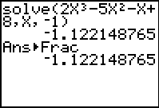
Rational Root Theorem
Let f(x) = a_{n}x^{n} + a_{n–1}x^{n–1} + … + a₁x + a₀ (a₀ ≠ 0) be an nth-degree polynomial with integer coefficients. If is a rational root of f(x) = 0, where is in lowest terms, then p is a factor of a₀ and q is a factor of a_{n}.

Practice
Have students work through the problems either in their textbook or from a worksheet to apply the theorem.

