Open the TI-Nspire document Enzyme_Chemical_Reactions.tns.  In this data-gathering activity, you will explore chemical reactions involving enzymes. You’ll see how enzymes are used to build larger molecules or smaller ones. |  |  |  | 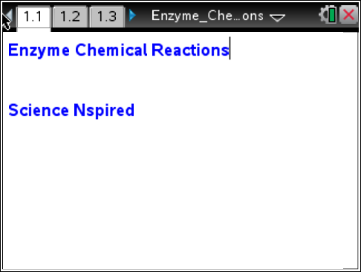
Background
When you put hydrogen peroxide on a cut, you’ll see bubbles form. There are enzymes in your blood that react with the hydrogen peroxide turning it into water and oxygen. Why does this occur? It actually happens a lot in your body.
Enzymes are biological molecules that your body produces and they quickly react with certain chemicals. For example, your cells produce hydrogen peroxide as a waste product, but it is toxic to the body. The body also produces an enzyme called catalase, which reacts with the hydrogen peroxide (H₂O₂) to break it down into two harmless substances, as shown here.
2H₂O₂ → 2H₂O + O₂
Two molecules of hydrogen peroxide are broken down into two molecules of water (H₂O) and one molecule of oxygen (O₂). The bubbling you see on the cut after applying hydrogen peroxide is the oxygen being released. There is a fair amount of catalase in blood! In addition, it can be found in many different tissues in both plants and animals.
In this experiment, you will measure the rate of enzyme (catalase) activity under various conditions. To do this, you will measure the pressure of oxygen gas in a flask as it is released during the chemical reaction between hydrogen peroxide and catalase.
Part 1 – Preliminary Questions:
Move to page 1.2.
1. Read the introduction on page 1.2. |  |  |  |  | 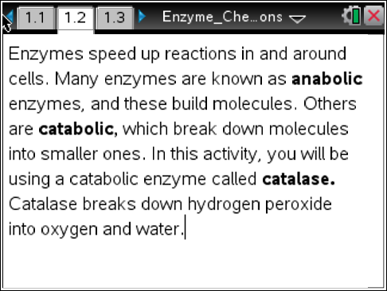
Move to pages 1.3 – 1.5. Answer questions 1 - 3 here and/or in the .tns file. |  |  |  |  | 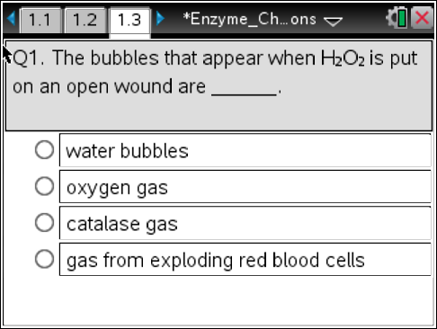
Q1. The bubbles that appear when H₂O₂ is put on an open wound are ____________.
A. water bubbles  B. oxygen gas |  | C. catalase gas  D. gas from exploding red blood cells
Q2. Catalase separates hydrogen peroxide into ____________.
A. water only  B. water and carbon dioxide |  | C. water and oxygen  D. water and hydrogen
Q3. Catalase is an example of ____________.
A. an enzyme  B. a blood cell |  | C. an atom  D. a gas
Part 2 – Reaction Rate Data Collection:
Move to page 2.1.  2. Page 2.1 is a blank DataQuest application. Connect the EasyLink to the TI-Nspire, and then connect the Gas Pressure Sensor to the EasyLink. Select Menu > Experiment > Collection Setup. Enter 1 for Rate and 30 for Duration to collect data every 1 second for 30 seconds. |  |  |  |  | 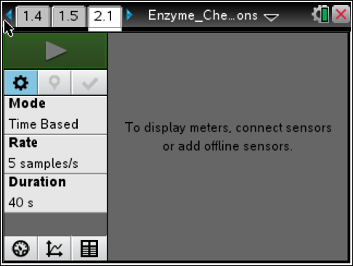
3. Attach the tube to the pressure sensor, and then attach the black stopper to the tube.
4. Use the graduated cylinder to measure 5 mL of hydrogen peroxide and pour it into the flask.
5. Draw 1 mL of the catalase suspension into the syringe.
6. Press Start Data Collection on the TI-Nspire, and immediately add the catalase suspension to the flask. Then, quickly put the stopper firmly in the mouth of the flask.
Move to page 2.2.  7. View the collected data in the Data & Statistics application on page 2.2. Use the Entry Line to set the x-axis (horizontal axis) to the variable run1.time and the y-axis (vertical axis) to run1.pressure. |  |  |  |  | 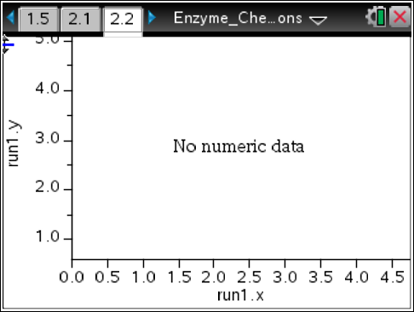
8. Use the Moveable Line tool (Menu > Analyze > Add Moveable Line) to fit a line to the collected data. Be sure to fit the line to the data collected during the initial phase of the chemical reaction.
Move to page 3.2.  9. Observe the slope of the fitted line to determine the rate at which the pressure of the gas changes. Record these data in the Lists & Spreadsheets application on page 3.2. |  |  |  |  | 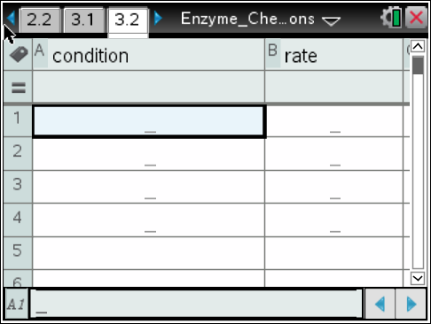
Part 3 – Manipulation of Reaction Variable:
10. Modify a variable from the investigation in Part 2 and then repeat steps 1–9. You may want to modify any of the following variables:
• Amount of hydrogen peroxide in the flask
• Amount of enzyme added to the flask
• Temperature of flask (placed in hot or cold water)
• Type of enzyme used (use “boiled” enzyme instead)
11. Repeat the experiment from Part 2 with a modified variable and view the collected data on page 2.2. Be sure to rinse and dry the reaction flask between experiments.
12. For each set of newly collected data, determine the rate of reaction and record it on page 3.2.
Part 4 – Analysis:
Move to pages 4.1 – 4.6. Answer questions 4 - 9 here and/or in the .tns file.
Q4. In this activity, hydrogen peroxide was the catalyst that was used to speed up the reaction.
A. True |  |  | B. False
Q5. When you used boiled catalase, you probably noticed a very slow reaction rate. Predict why this happened.

Q6. Which trial should have had the fastest rate of reaction? The trial using the flask that had ________________.
A. room temperature catalase  B. boiled catalase |  |  | C. catalase on ice  D. catalase in warm water
Q7. What was the result of increasing the amount of catalase used?

Q8. What was the result of decreasing the amount of catalase used?

Q9. As a variation of the experiment you could increase the amount of catalase but keep the amount of peroxide the same. How would the final pressure in the flask compare to that of the initial experiment (the control)?
A. It would be higher. | B. It would be lower. |  |  |  | C. It would be at the same level.

