Open the TI-Nspire document Average_Value.tns.  Objective: To examine areas as integrals and as rectangles for given functions in order to determine the properties of functions that allow the areas to be equal.  Directions: For each of the problems, move the open circle until the area of the rectangle matches the area under the curve. | 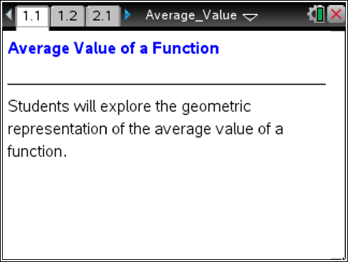

Move to page 1.2.

Record the function, limits of integration, and the c value (cval) for each problem.

Move to page 2.1.  Function:  Limits of Integration: | cval:
Move to page 3.1.  Function:  Limits of Integration: | cval:
Move to page 4.1.  Function:  Limits of Integration: | cval:
Move to page 5.1.  Function:  Limits of Integration: | cval:
Move to page 6.1.  Function:  Limits of Integration: | cval:

1. Was the c value always between the limits of integration?

2. What is the relationship between the area of the rectangle and the integral area?

3. What property of a function held when the areas were equal?

4. Can this relationship be written using calculus notation?

Notes: (Take notes here)

Exploration: (Record your solution here)

