Open the TI-Nspire document Natural_Logarithm.tns.  The purpose of this activity is to introduce one definition of the natural logarithm function, that is, . This activity allows you to visualize this definition and to discover some of the properties of the natural logarithm function and its graph. | 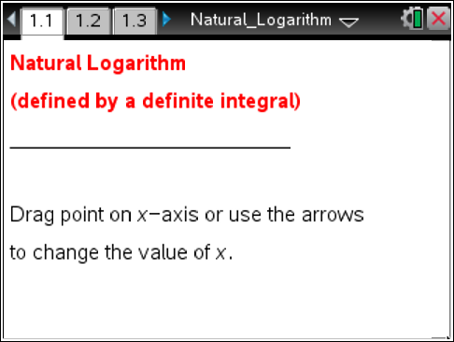

One way to define the natural logarithm function and to develop properties of this function involves the area under the graph of .
To begin this activity, let the natural logarithm function, denoted ln, be defined by , for
0 < x < ∞. (We'll see why there are some restrictions on the domain.) An interpretation of this definite integral is the area under the graph of , above the x-axis, and between the vertical lines at 1 and x. Using this geometric interpretation of the definite integral, you will learn some of the characteristics of the graph of y = lnx and properties of the natural logarithm function.

Move to page 1.2.
1. As you grab and drag point x to the right along the horizontal axis or use the up and down arrows the top-right portion of the page, the computed area of the shaded region is equivalent to lnx, the value of the natural logarithm function.

Tech Tip: To easily change the value of x, select the up and down in the top-right portion of the page. Also you can select the value and type in the number.
Tech Tip: With the iPad, touch your finger to the point and then drag it along the x-axis.
a. Complete the following table.

x | 1 | 1.5 | 2 | 4 | 6 | 8
lnx

b. Explain what happens to the value of lnx as x increases.

c. Explain your answer in part b geometrically.

2. Drag point x to the left of 1 (but greater than 0), or use the up and down arrows to change the value of x.
a. Complete the following table.
x | 1 | 0.9 | 0.7 | 0.5 | 0.2 | 0.1 | 0.05

b. Explain what happens to the value of lnx as x decreases (gets closer to 0).

c. Explain your answer in part b geometrically.

Move to page 1.3.
3. A part of the graph of y = lnx is displayed. Grab point x or use the up and down arrows to change the value and move it along the horizontal axis to the right to construct the remaining part of the graph of y = lnx. The values of the natural logarithm function are displayed on the right screen.
a. Explain what happens to the graph of y = lnx as x increases without bound (as x → ∞).

b. Explain what happens to the graph of y = lnx as x approaches 0 from the right (as x → 0⁺).

c. Explain why x = 0 is not in the domain of the function y = lnx.

d. The function is defined for x < 0. For example, f(–2) = . Explain why the definition of the natural logarithm function cannot be extended to include negative numbers.

e. Use the Fundamental Theorem of Calculus to find the derivative of f(x) = lnx. Determine the intervals on which the graph of y = f(x) is increasing and the intervals on which it is decreasing. Find the absolute extreme values for f. Determine the intervals on which the graph of y = lnx is concave up and the intervals on which it is concave down.

