Problem 1
Open the CabriJr app by pressing  and choosing it from the menu. Press . Press □ to open the F1:File menu. Arrow down to the Open… selection and press . Choose figure POINT1 and press . | 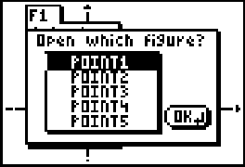
This figure shows a point P and its coordinates. You can use the arrow keys to drag the point. Drag point P around the plane, watching how each coordinate changes with the location of P. | 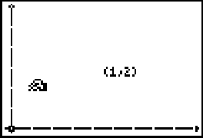
1. Try to move the point in such a way that the first coordinate stays the same.
What kind of movement do you make?

2. Now try to move the point in such a way that the second coordinate stays the same. What kind of movement do you make here?

Problem 2
Xavier and Yvette are playing a game in a fictional land called the Cartesian Plains. They keep track of their score by moving point P. Xavier’s score is the first coordinate, and Yvette’s score is the second coordinate.
To see their game, press □ to open the F1: File menu. Open figure POINT2. In the game shown, Xavier is in the lead, and the score is 6 to 2.5.  To move the point, first move the cursor to it using the arrows keys. The point is selected when the cursor turns white. | 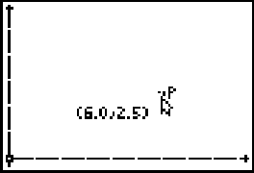
Press  to “grab” the point. The cursor turns into a hand.  You can now use the arrow keys to drag the point around the plane. Move point P to reflect different scoring situations in the game and to help you answer the following questions. Press  to let go of the point. | 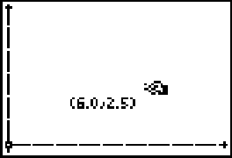
3. Where is a point when Xavier has scored no points?

4. Where is a point when Yvette has scored no points?

5. Where is a point when Yvette is in the lead with the most points?

6. Where is a point when Xavier is in the lead with the most points?

7. Where is a point when the score is tied?

Problem 3
Open the figure POINT3. This graph shows a certain scoring situation for Xavier and Yvette’s game.  8. Grab and drag point P, and describe what scores in the game are represented by the coordinates of this point P. | 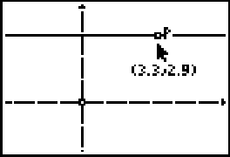
Open the figure POINT4. This graph shows yet another scoring situation for the game.  9. Grab and drag point P, and describe what scores in the game are represented by the coordinates of P. | 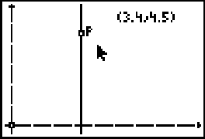
Problem 4
Open figure POINT5. This graph shows points X and Y, attached to the axes. Point P again represents the score in the game, which you can change by dragging points X and Y. Experiment with the scoreboard by dragging points X and Y, and thus changing Xavier’s and Yvette’s scores. | 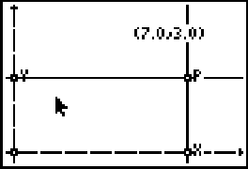
10. What line segment in the graph has a length equal to Xavier’s score?

11. What line segment in the graph has a length equal to Yvette’s score?

