Introduction
If you went to a pet store and bought a hamster for a pet, you probably would expect it to remain rather small for its entire life. You would feed your hamster every day and make sure it had enough water, and once it reached a hamster size, it would stop growing and remain that size for the rest of its life. Just imagine if this were not the case, and your pet hamster kept growing for its entire life span! You might end up with a hamster the size of a dog! Of course, hamsters do not grow forever; they have a size limit. This is typical of endothermic, or warm-blooded animals. Some animals, however, continue to grow until the end of their life spans. Many ectothermic, or cold-blooded animals are like this. The ectothermic vertebrates are fish, amphibians, and reptiles, and many of these animals can continue to grow until they die. |  |  |  |  |  | 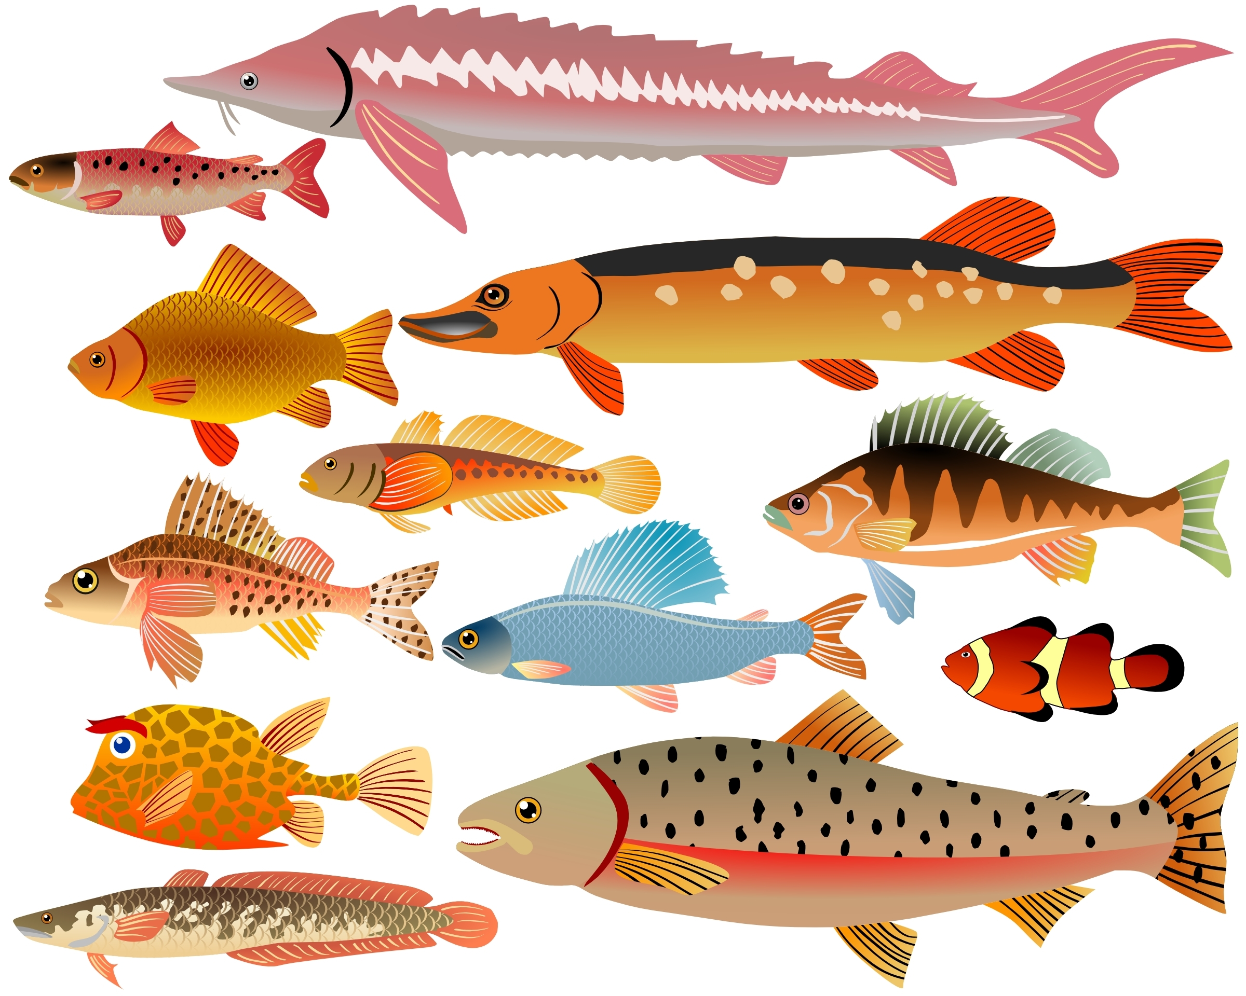  © Alexander Kovalenko | Dreamstime.com
Objectives
In this activity, you will:
- examine the growth rates of three different species of fish that are commonly caught by people who go fishing.
- enter and graph the data, and compare the growth rates of the three species of fish.
You’ll Need
- TI-84 Plus CE calculator
- Data Table of fish growth rates (below)

 | Northern Pike Length in cm | Northern Pike Mass in kg | Walleye Length in cm | Walleye Mass in kg | Largemouth Bass Length in cm |  | Largemouth Bass Mass in kg
 | 60 | 1.74 | 36 | .46 | 20 |  | .18
 | 62 | 1.80 | 38 | .54 | 22 |  | .26
 | 64 | 2.00 | 40 | .67 | 24 |  | .28
 | 66 | 2.27 | 42 | .70 | 26 |  | .37
 | 68 | 2.52 | 44 | .84 | 28 |  | .49
 | 70 | 2.77 | 46 | 1.00 | 30 |  | .63
 | 72 | 2.85 | 48 | 1.13 | 32 |  | .67
 | 74 | 3.18 | 50 | 1.34 | 34 |  | .84
 | 76 | 3.48 | 52 | 1.39 | 36 |  | 1.00
 | 78 | 3.82 | 54 | 1.56 | 38 |  | 1.27
 | 80 | 4.15 | 56 | 1.77 | 40 |  | 1.52
 | 82 | 4.26 | 58 | 2.03 | 42 |  | 1.81
 | 84 | 4.64 | 60 | 2.29 | 44 |  | 1.89
 | 86 | 5.06 | 62 | 2.36 | 46 |  | 2.23
 | 88 | 5.47 | 64 | 2.61 | 48 |  | 2.57
 | 90 | 5.60 | 66 | 2.95 | 50 |  | 2.99
 | 92 | 6.07 | 68 | 3.24 | 52 |  | 3.11
 | 94 | 6.59 | 70 | 3.62 | 54 |  | 3.59
 | 96 | 7.08 | 72 | 3.73 | 56 |  | 4.10
 | 98 | 7.58 | 74 | 4.11 | 58 |  | 4.65
 | 100 | 7.74 | 76 | 4.53 | 60 |  | 5.23
 |  |  | 78 | 4.95 | 62 |  | 5.41
 |  |  | 80 | 5.40

Entering the Data
- Press o. If there are any equations on this screen, press † to place the cursor next to Y1=, and then press ‘ ‚ to clear the equation. Repeat this sequence to clear all equations.
- Press z and make sure the defaults are set.
- Press y . and make sure the defaults are set.
- Press … Í.
- Press } to move to the heading L1. Press ‘ Í. Repeat this procedure for any list that has data.
- Using the data table on the previous page, enter the data into L1 (northern pike length) and L2 (northern pike mass). In L3 and L4, do the same for the walleye, and in L5 and L6 for the bass.
- To do this, type in the first number in L1 and then press either Í or † to move down to the next spot in the list. Continue until you have entered all of the northern pike length data in L1. When you complete the data from L1, press ~ to move to L2 and enter the northern pike mass data. Repeat this for the walleye and the bass in the remaining lists.

- Press y ,. Press Í to select 1:Plot1. Set your TI-84 as shown at the right. | 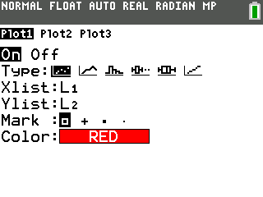
- Press y ,. Press Í to select 2:Plot2. Set your TI-84 Plus CE as shown at the right. | 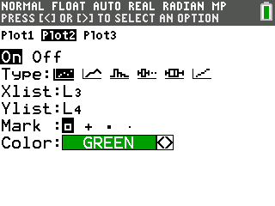
- Repeat for Plot3. Set your TI-84 Plus CE as shown at the right. | 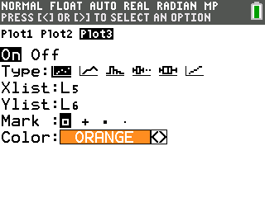
- Press p and make appropriate settings for the size of your graph. Your window must reflect ALL of the data in your lists, because you will be graphing all of the data at one time. A suggestion when setting your window is to set the Xmax value slightly lower than the lowest value in your lists, and the Ymax value slightly higher than the highest value in your lists. Remember, you have three x-lists and three y-lists to consider, and you will use one window setting for all of them.
- Press s to see your data displayed graphically.
Data Analysis
- When you construct your graphs, what is the independent variable?

- What is the dependent variable?

- Which species of fish appears to gain the most mass per cm of length?

- Suppose that you are out fishing, and you catch a 61-cm fish of each species. Draw what each fish would look like.

  - Northern Pike Walleye Bass

- As a northern pike grows from 68.6 cm to 71.1 cm, how much mass would the fish likely gain?

- As a northern pike grows from 92.9 cm to 96.5 cm, how much mass would the fish likely gain?
- What do you notice about the rate of mass gain in each fish? Explain why the mass gain per cm changes as the fish gets longer and longer.

- Fish of the same species and the same age but found in lakes of much different latitudes may be dramatically different in size. Describe some factors that may lead to these differences.

Going Further
- Find out what your state record and the world record masses are for each of these three species of fish. Using your graphical models, determine the predicted lengths of each of these record fish, and then compare your prediction to the actual lengths, if they are available.

- ·Draw two graphs of the growth of a pet hamster. Make age the independent variable for each graph. Make length the dependent variable on one graph and mass the dependent variables on the other. Explain why you drew your graphs the way you did. After you have finished drawing the graphs, try to duplicate them using your TI-84 Plus CE.

