Open the TI-Nspire document Boyles_Law.tns.  In this activity, you will use a Gas Pressure Sensor to measure the pressure of an air sample inside a syringe. Using graphs, you will apply your results to real-world examples. | 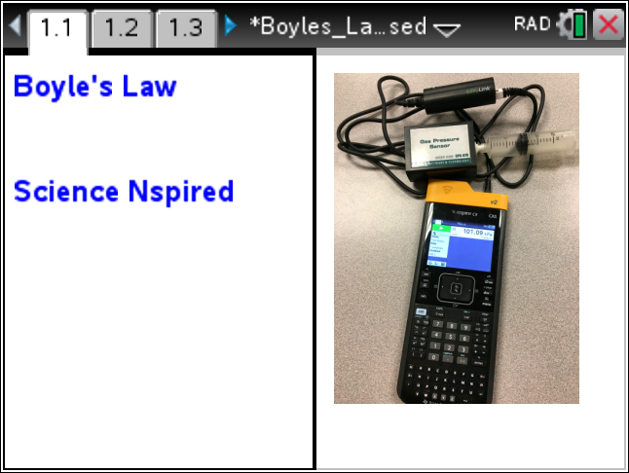

What is the mathematical relationship between volume and pressure for a confined gas? To answer this question, you will perform an experiment with air in a syringe connected to a Gas Pressure Sensor. When the volume of the syringe is changed by moving the piston, the change in the pressure will be measured. It is assumed that temperature and moles of gas will be constant throughout the experiment. Pressure and volume data pairs will be collected during this experiment and then analyzed. Using the data and the graph, the type of mathematical relationship between pressure and volume of the confined gas can be determined. Historically, this relationship was first established by Robert Boyle in 1662 and has since been known as Boyle’s law.
Read pages 1.2 – 1.4.
Move to page 1.5
Follow the directions given on page 1.4 for the simulation. Based upon the simulation of the molecules moving in the closed box, predict what a graph of pressure as a function of volume will look like. Sketch your prediction in the space to the right. Be sure to label the quantities on each axis.
Move to page 1.6.

Q1. As volume increases, the pressure ___________.
A. decreases B. increases C. remains the same
Move to page 2.1
Lab Procedure
- With the syringe disconnected from the Gas Pressure Sensor, move the piston of the syringe until the front edge of the inside black ring (indicated by the arrow in the picture to the right) is positioned at the 10.0 mL mark
- Turn on your TI-Nspire handheld, and close any documents that are open.
- Attach the syringe to the Gas Pressor Sensor as shown to the right. (Do not twist too tightly—the syringe just needs to be secure.)

Move to page 2.2.
- Plug the pressure sensor into the EasyLink™, and plug the EasyLink into the USB port in the top of the handheld.
- What is the default unit for collection with this sensor?
- Select MENU > Experiment > Collection Mode > Events with Entry.
- Type in volume for Name, press e, and type mL for Units. Press ·.
- Click the Start button to start data collection, or press e until the Start arrow is highlighted, and then press · when ready. It is best for one person to take care of the syringe and for another to operate the handheld.
- To collect the first data reading, click on the Keep button to save the data. Enter a value of 10+0.8, since you set the syringe at 10 mL earlier. The 0.8 accounts for the volume of air in the stem of the syringe. Click on OK, or press ·.
- Depress and hold the plunger to the 9 mL mark. When the pressure value on the left side of the screen has stabilized, click on the Keep button, type in 9.8, and press ·.
- Continue this procedure, collecting data at 8, 7, 6, and 5 mL. After you have collected data for 5 mL, you may want to pull the plunger out to collect data at 12 and 14 ml. Be sure to add 0.8 to each reading. When you have finished collecting data, click on the Stop button.

- How does the graph of the data compare to your prediction?

- Discuss the possible mathematical models for this data set.

- Based on the graph of pressure versus volume, decide what kind of relationship exists between these two variables—direct or inverse. Explain your reasoning.

Computing a regression equation:
- While on the DataQuest app page, select MENU > Analyze > CurveFit > Power.
- Scroll down to see the curve fit statistics for the equation in the form y = a ⋅ x^{b}, where x is volume, y is Pressure, a is a proportionality constant, and b is the exponent of x (volume).
- If the mathematical relationship has been correctly determined, the regression equation should closely fit the points on the graph (that is, pass through or near all of the plotted points).
- Examine the sign of the exponent. What does the sign indicate about the relationship?

- Write the equation that models the data in two different ways.

Move to pages 2.3 - 2.5.
Q2. Which variable is considered to remain constant during a Boyle’s Law Experiment?

A. pressure B. volume C. temperature D. all of the above

Q3. When a quantity of gas is compressed, the pressure of the gas is expected to _______.

A. decrease B. remain the same C. increase D. double

Q4. The expected mathematical relationship between pressure and volume is __________.

A. direct B. inverse C. indirect D. impossible to determine

Read page 3.1, and then return to page 2.2.
- To linearize the data and confirm that a reciprocal relationship exists between pressure and volume, plot a graph of pressure vs. reciprocal of volume (1/Volume) in DataQuest.
- Click on the Table View.
- Select MENU > Data > New Calculated Column.
- Type RecipV for Name.
- Short Name: 1/V
- Units: 1/mL
- Expression: 1/Volume (Be sure to type Volume with a capital V.)
- Click OK, or press ·.
- Select MENU > Graph > Select X-axis Variable > RecipV.

- Calculate the regression line y = mx + b where x is 1/volume, y is pressure, m is a proportionality constant, and b is the y-intercept. Select MENU > Analyze > Curve Fit > Linear.

- Write the equation for the linear regression of Pressure as a function of 1/V.

- How is the linear regression equation related to the equation that you determined for Pressure as a function of Volume?

Move to pages 3.2 – 3.9.
Q5. If the volume is doubled from 5 mL to 10 mL, what happens to the pressure?

A. increases B. decreases C. doubles D. cut in half
Q6. If the volume is halved from 20 mL to 10 mL, what happens to the pressure?

A. increases B. decreases C. doubles D. cut in half
Q7. Based on the data, what would be expected to happen to the pressure if the volume in the syringe were increased from 10 mL to 40 mL?

A. increase B. decrease C. quadruple D. cut to 1/4th
Q8. From the answers to the above three questions and from the shape of the curve of the plot of pressure vs. volume, what is the relationship between the pressure and volume of a confined gas?

A. inverse B. direct C. quadratic D. not possible to determine
Q9. What two experimental factors are assumed to be constant during this experiment? (Select two.)

A. pressure B. volume C. moles of gas D. temperature
Q10. Using P, V, and k, write an equation representing Boyle’s Law.

Q11. Which of the following produced a constant value?

A. pressure times volume B. pressure divided by volume
C. volume divided by pressure D. none of the above

Q12. Summarize what you have learned about the relationship between pressure and volume.

Move to page 4.1.
Extension: Effect of Temperature on Boyle’s Law
Follow the instructions on pages 4.1 - 4.3 for the simulation, and then answer the following questions from pages 4.4 - 4.6.

Q13. When the temperature is doubled, how does the pressure change?

A. The pressure doubles. B. The pressure is reduced by one-half.
C. The pressure is four time larger. D. The pressure does not change.

Q14. At a higher temperature, the relationship between pressure and volume is a(an) _______ relationship.

A. direct (a change) B. inverse (same as before)
C. quadratic (a change) D. impossible to determine (a change)
- Vary only one variable at a time, temperature or volume. Write about your observations of pressure based upon these changes.

