Open the TI-Nspire™ document Families_of_Functions.tns.  What effect does changing the parameters of an equation have on its graph? In this activity, you will explore the effects of changing the parameters one at a time. | 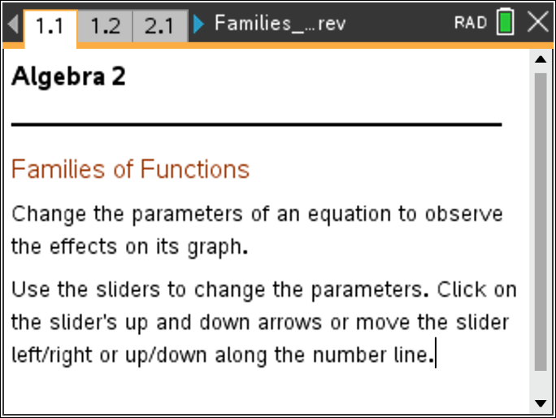

Move to page 1.2.

Perform the following actions for each page in the TI-Nspire document, and then fill in the table below.
- Click the slider (up or down arrow) on each page to manipulate the variable a. Note what a does to the graphs of the functions on each page.
- Grab and drag the slider point h on each page to manipulate the variable h. Note what h does to the graphs of the functions on each page.
- Grab and drag the slider point k on each page to manipulate the variable k. Note what k does to the graphs of the functions on each page.

Page | Parent Function  (Equation or Type) | Sketch of Parent Function | Effects of Parameter  a | Effects of Parameter  h | Effects of Parameter  k
1.2
2.1
3.1
4.1
5.1
6.1
7.1

1. Given any function, describe the effects parameter a has on its graph when:
a. |a| > 1

b. 0 < |a| < 1

c. a < 0

d. a = 0

2. Given any function, describe the effects parameter h has on its graph when:
a. h > 0

b. h < 0

c. h = 0

3. Given any function, describe the effects parameter k has on its graph when:
a. k > 0

b. k < 0

c. k = 0

4. Given the following functions, describe the transformations on the parent function, f(x).
a. f(x) = x²; h(x) = 3(x – 4)² + 2

b. f(x) = x³; g(x) = –(x – 1)³

5. Given the following transformations, write the equation of the function.
a. The graph of is reflected over the x-axis, vertically stretched by a factor of 2, and translated vertically down 1 unit.

b. The graph of f(x) = |x| is translated horizontally to the left 3 units and translated vertically up 5 units.

