Open the TI-Nspire document Corresponding_Parts_of_Congruent_Triangles.tns.  In this activity you will explore corresponding parts of congruent triangles and why they are important. | 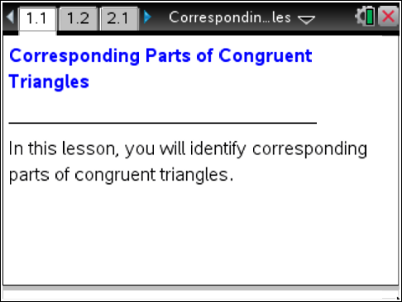

Move to page 1.2.

- You have three angles and three segments. Move the angles and segments by grabbing the open and closed circles on each.
- What happens when you grab and move the open circle?

- What happens when you grab and move the closed circle?

- Drag and rotate the segments and angles to create a triangle.
- Which parts did you use?

- Which parts were left unused? How do the unused parts relate to the triangle you created?

- a. Use the up and down arrow at the bottom of the screen. Describe what happens.

b. Move △ABC on top of the triangle you built. What relationship between the two triangles do you observe?

- Describe how the six parts of the triangle you made relate to the parts of △ABC.

Move to page 2.1.
- Grab the open circle and move the triangles.
- About which segment is △XYZ reflected when you use the up and down arrow?

- What is the relationship between the two triangles? How do you know?

- Identify the corresponding parts of the two triangles.

- Mark the triangles shown in the picture in some way to show which parts are congruent. | 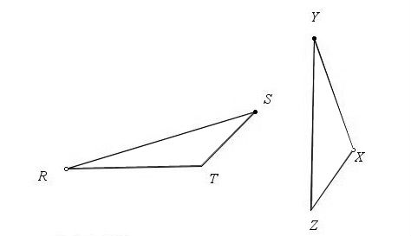
- When two triangles are congruent the congruence statement is △ANR ≅ △DBC where ∡A corresponds to ∡D, ∡N corresponds to ∡B, and ∡R corresponds to ∡C.
- Write a congruence statement for the two congruent triangles in question 5.

- Is this a valid statement for the two triangles? △XYZ ≅ △RST. Explain why or why not.

- Given: △SLY ≅ △FOX.
- Identify all of the corresponding parts of the two triangles.

- Write all other possible congruence statements for these triangles.

- You have identified corresponding parts of congruent triangles. How would you explain the importance of corresponding parts of congruent triangles to someone who has missed the class?

