Open the TI-Nspire document Need_for_Speed.tns.  Enzymes are very important biological molecules. Their job is to speed up reactions in and around cells. Many enzymes are known as anabolic enzymes, and these build molecules. Others are catabolic, and break down molecules into smaller ones. In this activity, you will be using a catabolic enzyme called catalase. Catalase helps break down hydrogen peroxide into oxygen and water.  Have you seen the effects of the reaction between hydrogen peroxide (H₂O₂) and catalase? If you have ever put H₂O₂ on a cut and seen the bubbles that form, you have witnessed this chemical reaction! | 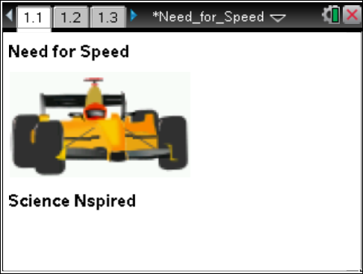

Move to page 1.2.
1. The play and reset buttons in the upper left corner stop and start the animation. Start the animation.  Note: Be sure to pause the animation before you move to the next page. ( ) |  |  | 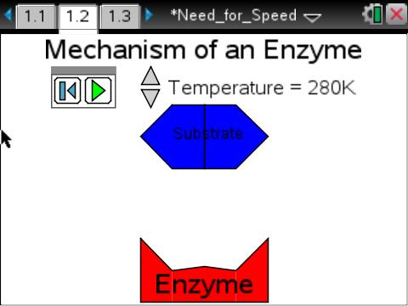
Tech Tip: To access the Directions again, select > Need for Speed > Directions
Tech Tip: To access the Directions again, select selecting b or Document Tools () > Need for Speed > Directions.
Tech Tip: Inform students that the animation on page 1.2 must be paused before moving on. This will be critical when they get to the animation on page 1.7.
Move to pages 1.3 and 1.4. Answer the following questions here or in the .tns file.
Q1. The simulation on the previous page represents a catabolic reaction. True or False?

Q2. What is the name of the region on the enzyme where the reaction took place?

Move to page 1.5.  2. Grab and move the slider bar to the right and notice what changes occur. |  |  | 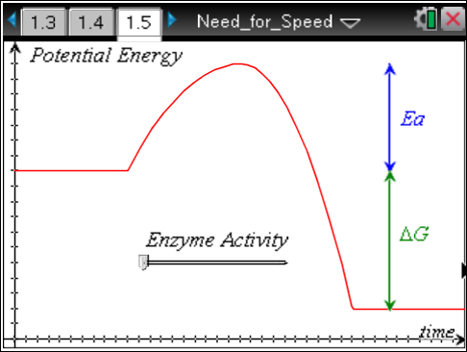
Move to page 1.6. Answer the following questions here or in the .tns file.
Q3. Which of the following changes with the use of an enzyme?
A. energy of the products | B. activation energy, E_{a} | C. free energy, ∆G
Move to page 1.7.  3. The simulation models the effect that temperature has on enzyme activity. The circles represent substrate molecules (in this case, H₂O₂). As the reaction proceeds, the concentration of substrate molecules decreases.  Change the temperature to 35°C and click on the play button(). Once all of the circles have disappeared, advance to page 1.8. |  |  | 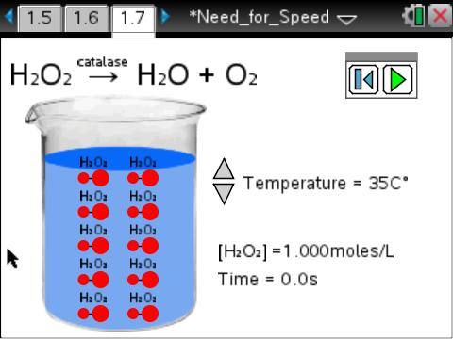
Move to page 1.8.  4. You will need to select the correct labels for the x- and y-axes to view the graph of the relationship. Select “concentration” on the left of the graph and choose concentration. The graph will appear. |  |  | 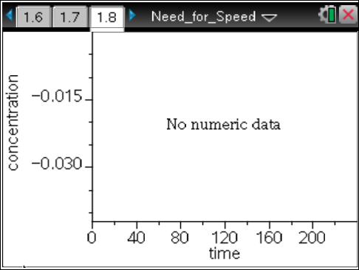
Answer the following questions here or in the .tns file.
Q4. Describe the relationship between substrate concentration and time during an enzymatic reaction.

Move to page 1.9.  5. In column A, label time. In column B, label concentration. In column C, label lnc (which stands for the natural log of concentration). Arrow down to the equation box in column C. Click on the natural log key (/ u). Type the letter b inside the ( ) and press ·. Data will now appear in column C. |  |  | 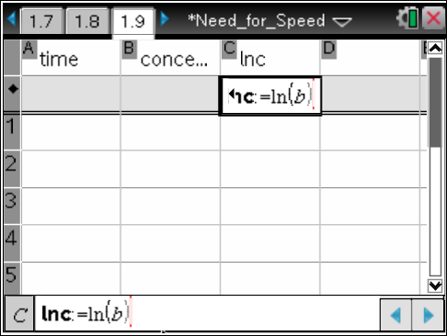
Move to page 1.10.
6. Graph lnc versus time. This will generate a line that you can analyze to determine the reaction rate. Perform a linear regression on this graph by pressing Menu > Analyze > Regression > Show Linear (mx+b). Record the temperature and the slope (or reaction rate) for that temperature in the table below.

 | DATA TABLE
 | Temperature (°C) | Slope of lnc Curve (Reaction Rate)
1. | 10°C
2. | 20°C
3. | 30°C
4. | 40°C
5. | 50°C

Tech Tip: To perform a linear regression on this graph, select > Analyze > Regression > Show Linear (mx+b).
Return to page 1.7.
7. Click on the reset button () on the left. Select a different temperature and click on the play
button ().
Advance to page 1.8 and watch the graph being generated.
When the graph is completed, advance to page 1.10. Record the slope of the ln (concentration) linear regression for the new temperature. Return to page 1.7 and repeat for three more temperatures for a total of 5 samples.

Q5. Analyze the data in the chart. Describe the pattern that is illustrated by the data.

