Problem 1 – Free Throws
You are watching a basketball game. There is no time on the clock and your favorite team is down by one point. A 70% free throw shooter is fouled and will be able to shoot two free throws, each worth one point. You will use a simulation to find the probability that your team will win the game without any overtime.

A random number generator can be used to help simulate the problem. In this case, use the digits 0 – 9. Choose 7 of them (or 70%) to represent a completed basket and 3 of them (or 30%) to represent a miss. You will simulate 100 trials, which is 100 two-shot opportunities.

Open the List Editor by pressing Se. Let 0, 1, 2 represent a miss and let 3 – 9 represent a made shot.

Step 1: Simulate the first shot by using the randInt( command in the formula bar of L1. RandInt( is found by pressing m and arrowing to the PRB menu. Set the lower:0, upper:9, and n:100. Once the information is entered, arrow to Paste and press Í. | 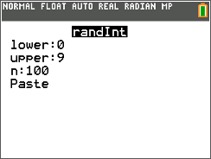  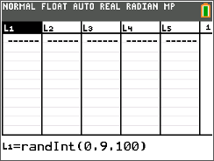
Step 2: Evaluate if a basket is completed by typing L1>2 in the formula bar of L2. Press y : to enter >.  A 0 will indicate a missed basket and a 1 will indicate a completed basket. | 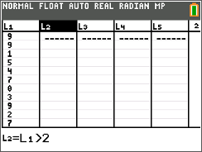
Step 3: Repeat steps 1 and 2 to simulate the second shot in L3 and L4. | 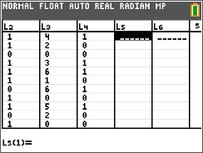
Step 4: Calculate the number of baskets made per trial by typing L2+L4 in the formula bar of L5. | 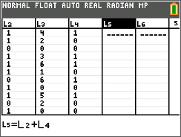
Step 5: Evaluate if a trial is a win for the team by typing L5=2 in the formula bar of L6.  The ones represent a "match" (both shots were made).  The zeroes represent "no match" (both shots were not made). | 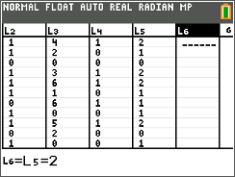
Step 6: On the Home screen, calculate the number of wins out of 100 trials by choosing the sum( command by pressing y 9 and arrow to the MATH menu. Type L6 (or select it from the menu). Press Í to view the sum. | 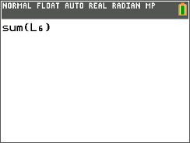
1. What is the experimental probability that your team won?

2. How does it compare to the theoretical probability?

3. If the percentage of the free throw shooter decreased to 60%, how much would the probability of your team winning decrease?

4. If the percentage of the free throw shooter increased to 80%, how much would the probability of your team winning increase?

Problem 2 – Birthday Problem
There are 25 unrelated people in a room. What is the probability that two of them share the same birthday?
Take a guess. What do you expect the probability to be?

Now, let’s investigate. How can random numbers be used to represent this problem? Discuss ideas with your group.
Clear any data from the lists (arrow to the top of each list and press C).  Step 1: Simulate the day of each person’s birthday using the command randInt(1,365,25) in the formula bar of L1. | 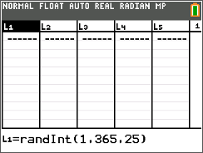
Step 2: Sort L1 to see if any numbers are the same. Arrow to the top of the list. Then press … and choose SortA(, type L1, and press Í. This will sort the birthdays in ascending order. Return to the List Editor to view the sorted birthdays. Use the arrow keys to scroll through the list.  Do you have two people with the same birthday? | 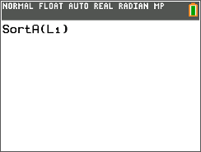
Step 3: Repeat this process 9 more times. You will need to re-enter the formula to randomly generate the birthdays because it was overwritten with the sort. You will also need to resort the list. Keep a tally of how many trials there are with same birthdays.

5. What is the experimental probability of having a shared birthday?

6. How does it compare to the theoretical probability?

7. What happens to the experimental probability if the number of the people in the room increases? Decreases?

8. What birthday was not included in this simulation?

Extension – Casey at the Bat
There is a famous poem titled Casey at the Bat by Ernest Lawrence Thayer. Your teacher will provide you with a copy. After reading the poem, let’s change the scenario just a little.
Let’s assume the coach of the Mudville baseball team knows two things: (1) Casey is a poor hitter and (2) the pitcher for the opposing team throws strikes only 40% of the time. So, the coach tells Casey not to swing the bat. What is the probability that Casey walks to first base?
Create a simulation that will represent the scenario above. Remember, three strikes and Casey’s out; four balls and Casey walks to first base.

9. Discuss ideas with your group. As a group, decide on the specifics for the simulation. Record them below.

10. Perform your simulation 25 times and record the experimental probability below.

11. How does the experimental probability compare to the theoretical probability?

12. Did the coach make a good decision?

