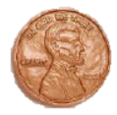
Introduction
In this activity, you will collect data on a 1 cent coin (penny) as it falls on its own, after being placed on its edge 25 times. You will then analyze your class’ data using a scatter plot and determine the experimental probability of getting a head or a tail.  You will tally your results as shown here.
  HEADS | TAILS
  ||| | ||||
Objectives
In this activity, you will:
- Enter the data into your handheld.
- Examine the data from the collective class and discuss patterns revealed in the data.
- Set up a Scatter Plot of the data.
- Identify the mathematical relationship in the plot.
- Explore what we have discovered in relation to the y=x function.
You’ll Need
- TI-84 Plus CE
- One penny
Collecting the Data
Find a level table top with a “sweet spot” where you can easily place your coin on its edge. Place the coin on its edge and wait until it falls on its own. Don’t hit the table or blow on it. Just wait until it falls. Tally your result, Heads or Tails, and repeat the event for a total of 25 times.
  HEADS | TAILS
Entering the Data
- Share your results with your teacher, so he or she can compile a list for the “class data”.

- Clear all the lists on your calculator by y L select 4:ClrAllLists and press Í. | 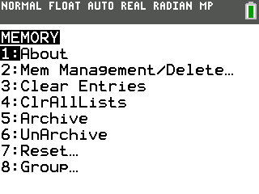
- Press … Í. Name the list HEADS by pressing } until you get to the very top of L1. Be sure to highlight the heading L1 and not just the first line in L1. Press | then ~ to get to an unnamed list. Name the list HEADS and press Í. Make sure you are in alpha lock mode by pressing y 7.  - Enter the class HEADS data into the list. | 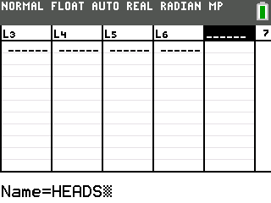
- Press ~ to highlight the next unnamed list. Name the list TAILS. Make sure you are in alpha lock mode by pressing y 7.  - Enter the class TAILS data into the list. | 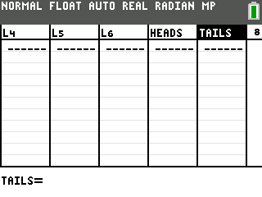
Analyzing the Data
- What is the maximum number of heads of any one group?

- How about the minimum number of tails?

- Do you see any pattern?

- What could you do if one student reported the number of heads but left the room before they told the number of tails?

- If we plot the data with HEADS as the X-values and TAILS as the Y-values, what do you think the graph will look like? Sketch it here: |  | 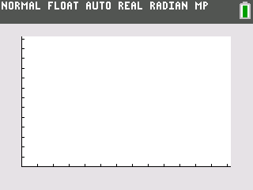
- Now set up the plot. Press y , Í to set up Plot1. Press y 9 and select HEADS for the Xlist and TAILS for the Ylist. |  | 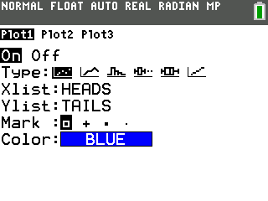
- Press o to make sure there are no equations in the Y= Editor. Press ‘ to erase any equations.
- Set up your window by recalling the maximum and minimum values for HEADS and TAILS. |  | 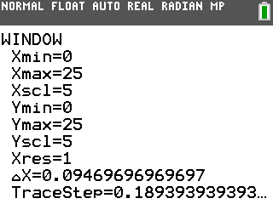
- Press s to see the plot of your data. |  | 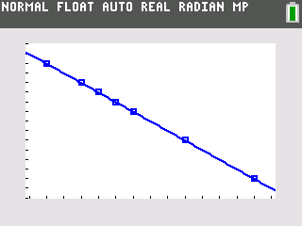
- What pattern do you see? What does the graph mean?

- Press o to return to the Y= Editor and enter in the equation that models the pattern. If you need to you could do a regression. Look at the plot with the equation. Did you get it?
- Let’s compare this with the y=x equation. That is the number of TAILS = the number of HEADS. Press o and go to Y2 and enter X. | 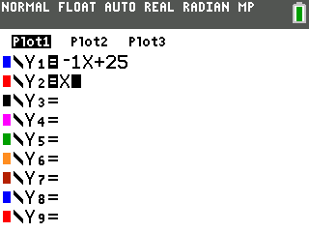
- Return to the graph (press s) and explain what it means to be in the areas I, II, III, and IV.  What does it mean to be on the lines?  You can just move around on the screen with your arrows | ~ } † or press r to follow on the lines. Press † } to switch what you trace on. | 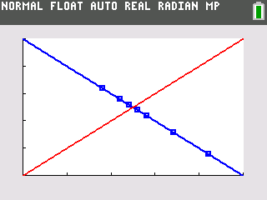  I  II  III  IV
- Now we want to look at the probability that the coin will fall showing heads. Return to the List Editor by pressing … À. Move over to the third column and using the technique you used before name a list for the total number of heads – THEAD. | 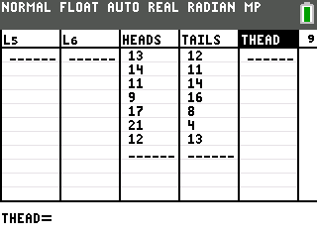
- While still in the header of the list get the cumulative sum operation. Press y 9 ~ 6:cumSum. Then tell the TI-84 which list you want to sum. Press y 9 and find the HEADS list. Press Í to finish and find the sum. | 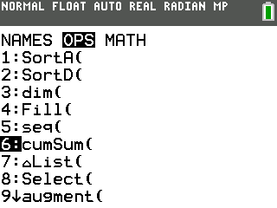
- Now we need the total numbers of falls. Make a fourth list named TFALL. Another way we can fill a list is with the sequence operation. This will work because we know the falls were 25, 50, 75, … since everyone did this 25 times. To get the values, while you are still in the header of the TFALL list as shown, press y 9 ~ 5:seq(.The syntax for sequence is seq(variable, rule, start, end, step). So your need to know how many total falls you had in order to fill in the form. In the sample shown you have 400. seq(X,X,25,400,25). | 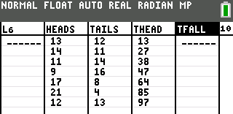  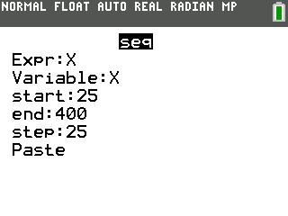
- To get the probability we need to divide the total heads by the total falls. In the sample we have 13/25 = 0.52 or 52%. Create a new list named PROB to hold these values. While still in the header tell the computer to do this calculation; LTHEAD/LTFALL. Press y 9 to get the names of the lists. | 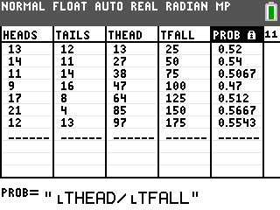
- Notice the numbers are all between 0 and 1. When you flip a coin you expect 50% of the time you will get heads.
How many of your data points are more than 50%? What does that mean?

- Set up a plot of PROB vs. TFALL and see how the probability is revealing itself with repeated trials. Don’t for get to turn off your Y= equations and to reset the window. Press y , À to set up Plot1 as shown. | 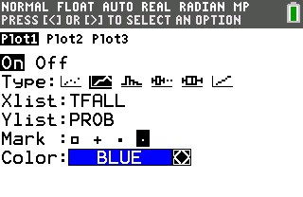
- We will set up the window manually. Press p and enter the data as shown, with the exception of Xmax. This number will be determined by the total number of falls that your class had. | 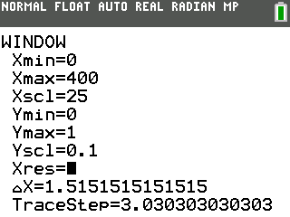
- Now look at the plot by pressing r.  What do you think the probability is tending toward? | 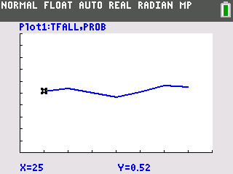
- Look at the average of the probabilities to help. Press o and move to a free line. Key in the key word for average by pressing y 9 | Â. Now select the list you want the mean of by pressing y 9 and find the PROB list. Change the color of the line by pressing | to highlight the line properties and press Í. Use the arrows to select the color you like then arrow down to OK and press Í. | 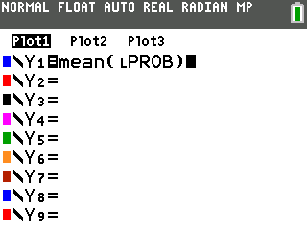  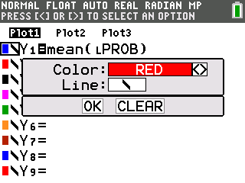
- Press s and see the Truth. | 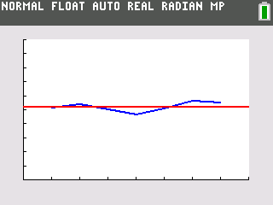
- Finally, examine your coin with a magnifying device. Do you notice anything that might cause your coin to fall over one way more often than the other? Ask your teacher (or use the web) to understand the concept of center of mass. Explain your findings.

