Open the TI-Nspire document Heart_and_Lungs_The_Beat_Goes_On!.tns.
Your respiratory system moves gases in and out of your body. Your cardiovascular system moves blood around your body. Pulmonary circulation links the heart and lungs. Systemic circulation sends oxygen-rich blood to the body and returns oxygen-poor blood to the heart. Vital signs in both systems change during exercise. For example, the levels of oxygen and of carbon dioxide in the blood change.
Move to page 1.2.
1. The graph on page 1.2 represents respiratory response data from a student during three “Situations.” Select the right arrow ¢ in the top left of the screen and look for any changes in the shape of the graph that take place. |  |  | 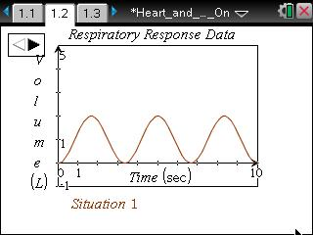
Move to pages 1.3–1.5. Use the Situation 1 Graph, answer questions 1-3 here and/or in the tns file.

Q1. What is the height of a wave crest, or the amplitude, measuring?
A. amount of air moving in and out of the lungs | B. respiratory rate |  | C. time
Q2. What is the number of wave peaks in 10 seconds, or the frequency, measuring?
A. amount of air moving in and out of the lungs | B. respiratory rate |  | C. time
Q3. What was the student most likely doing during Situation 1 of the data collection?
A. hyperventilating  B. holding a breath |  | C. increasing physical activity  D. breathing normally
Return to page 1.2. Answer questions 4-9 here on the activity sheet.

2. Select the right arrow ¢ in the top left of the screen to see the graph for Situation 2.
Q4. What was the student most likely doing during Situation 2 of the data collection?
A. hyperventilating  B. holding a breath |  | C. increasing physical activity  D. breathing normally
Q5. Using the terms frequency and amplitude, explain your answer choice for Question 4.

3. Select the right arrow ¢ in the top left of the screen to see the graph for Situation 3.

Q6. What was the student most likely doing during Situation 3 of the data collection?
A. hyperventilating  B. holding a breath |  | C. decreasing physical activity  D. breathing normally
Q7. Using the terms frequency and amplitude, explain your answer choice for Question 6.

Q8. Breathing in brings oxygen to the blood, and breathing out carries carbon dioxide out of the blood. When a person exercises, it creates more carbon dioxide, or CO₂, in their blood. For each Situation, describe how the level of CO₂ in the student’s blood changes over the 10 sec period.

Q9. Look at the overall pattern of each graph on page 1.2. For each Situation, describe the effect that changes in CO₂ levels had on the volume of air and on the respiration rate.

Move to pages 2.1 and 2.2. Answer questions 10-13 here on the activity sheet.

The graph on page 2.2 represents the heart rate data for a well-conditioned athlete performing a 200-second stress test of the following:  a. Standing still for 40 sec.  b. Running in place for the next 60 sec.  c. Standing still for the remaining 100 sec. |  | 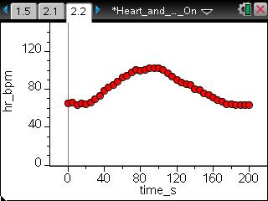
 | Tech Tip: The data points will appear more spread out than in the screenshot above because of variations in the display area.
Q10. An athlete participates in exercise often, which means that their muscles, including their heart, get stronger. When a muscle gets stronger, it can use less effort, or energy to accomplish the same task. What effect on a person’s heart beat would you expect to see as their heart gets stronger?

Q11. On the graph below from page 2.2, sketch a graph for a non-athlete who is performing the same activity.

Q12. Explain your reasoning for how you sketched the non-athlete’s graph in Question 11.

4. Now check your answer to Question 11 by selecting Menu > Plot Properties > Add Y Variable > hr2_bpm to add the data for the non-athlete.

 | Tech Tip: To add data for the non-athlete, select  > Plot Properties > Add Y Variable > hr2_bpm. You may need to back-out to the main Tools Menu to see the desired menu option.
Q13. Describe how your prediction graph compares with the graph on your device. Note: Ignore the auto-window which adjusts the y-axis.

