Open the TI-Nspire document Eating_and_Exercise.tns.  In this simulation you will input Biometrics, the measurement of physical or behavioral traits such as lifestyle, age, height and weight. You will also input your BMI or Body Mass Index, or measure of body fat based on height and weight. Then you will enter the food you ate yesterday or your approximate average daily food intake. The .tns will calculate the number of proteins, | 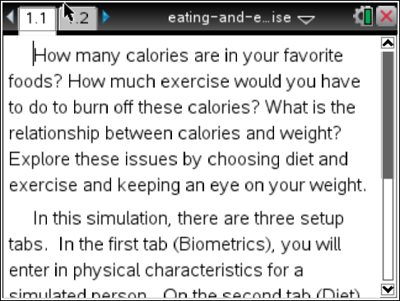
carbohydrates (carbs), and fats you ate. Next you will use a formula to figure out the percentage of proteins, carbohydrates, and fats you ate (or normally eat) and compare these percentages to those recommended. Next you will input your daily exercise and observe the effect it has on your basic metabolic rate or BMR. (BMR is the number of Calories you burn while resting.) Finally, the .tns will generate graphs showing your typical intake of Calories versus Calories burned. A corresponding graph will show anticipated weight gain, loss, or retention over a period of time. At the end of this simulation you will see how food and exercise choices affect weight, one good health indicator.
You can use this simulation to help you make healthy lifestyles choices. The .tns will calculate Calories and the number of Calories you eat from proteins, carbs, and fats. Then you will use a formula to figure out the percentage of proteins, carbs, and fats you usually eat in a day. You will compare this information to the recommended daily allowances for middle school students:

proteins 10%-30%, carbohydrates 45%-65%, fats 25%-35%

Notice how your BMR changes as you exercise more or less. Remember that it is important to be conscious of both eating too few or too many calories and too little or not enough exercise. Keeping a healthy balance between food and exercise is important way to maintain good health. Also note how your Body Mass Index (BMI) can change. To determine BMI, use weight in pounds (lbs) divided by height in (in) squared multiplied by a conversion factor of 703 (or use Internet sites such as http://www.nhlbisupport.com/bmi/ to do the calculation.) See if you are within a healthy weight range. Here are the ones recommended: Underweight = <18.5; Normal weight = 18.5–24.9; Overweight = 25–29.9; and Obesity = BMI of 30 or greater. If you are not within a desirable weight range, how much weight you would you need to gain or lose?
Move to page 1.2. Answer questions on your activity sheet.
On page 1.2, you will find three tabs⎯Biometrics, Diet, and Exercise. Select the button on any tab to change your input.

- Select the first tab Biometrics. Set up your Biometric information. Choose Female or Male, and your Lifestyle (use up and down arrows to select from the menu). Then enter your Age, Height in feet and inches, and Weight. (Note: The percent body fat will be calculated automatically.) Select · after you enter the value for each variable and note your BMI. | 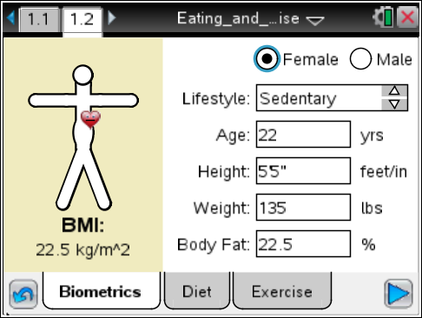

Tech Tip: When you select Age, Height, or Weight, the keyboard will appear on the screen. To enter numerical values, select the button “.?123” to the left or right of the space bar. After you have entered the numerical value, select “return” to return to the main screen.

- Select the Diet tab. Enter the food you would normally eat during one school day for breakfast, lunch, dinner, and dessert/snack. Include drinks you normally have with each meal and snack. Grab and drag the scroll bar on the right to show more choices for lunch, dinner, and drinks. Use the up and down arrows to indicate amounts. |  | 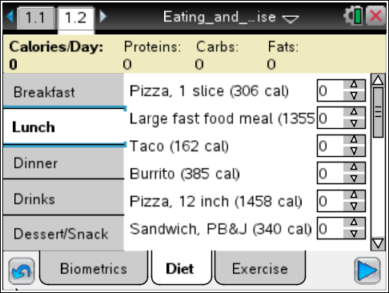
- When you have finished, note that the number of Calories from these nutrients: proteins, carbs (carbohydrates), and fats are shown at the top of the page. Record these amounts below.

Total Calories/Day: _____
Proteins: _______ Carbs: _______ Fats: _______

Q1. Divide the number of Calories from proteins, carbs, and fats by the total number of Calories and multiply by 100. This calculates the percentage of Calories from each nutrient.

Q2. How do your percentages of these nutrients compare with the recommended percentages for middle school students (proteins 10% – 30%, carbs 45% – 65%, fats 25% – 35%)?

4. Select the Exercise tab. Use the up and down arrows to enter the time you spend doing each type of activity for the selected day of the week. For example, if you ride your bike for an hour, or 60 minutes, you would enter 4 because the time listed is 15 minutes (). Grab and drag the scroll bar on the right for more choices. Estimate times as required.  Q3. As you add activities, what do you notice about the changes in the total calories burned for Exercise?  Move back to Biometrics.  5. Change your lifestyle to one that is more or less active. | 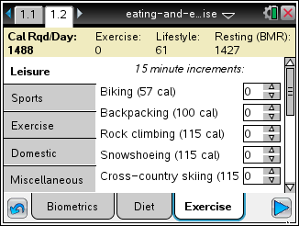
Move back to Exercise.  Q4. What do you notice about how the Lifestyle number changes as a result of the change you made in Step 5 above?  Q5. How does the combination of numbers for Exercise, Lifestyle, and Resting (BMR) affect the Calories/Day (calories burned per day)? Why do you think this is so?  Q6. If you want to maintain your current weight, how do you get the total Calories per day burned to equal total Calories consumed?  6. Now select the arrow  on the bottom right of the screen. This will show a timeline graph that compares the amount of calories you consume every day compared with the amount of calories you burn.  Q7. What happens to your weight over time if your current intake of food and exercise stay the same? | 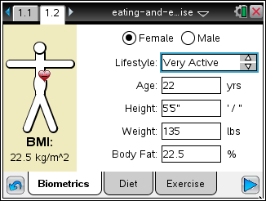
Move back to Diet.  7. Keep the biometrics and exercise you entered previously the same. Change at least one food for each meal, breakfast, lunch, dinner, and dessert/snack to ones you think are healthier.  8. Select the arrow and observe any changes in all the lines on the graph.  9. Now set weight goals for you based on the information in the introduction about BMI and a Normal weight range.  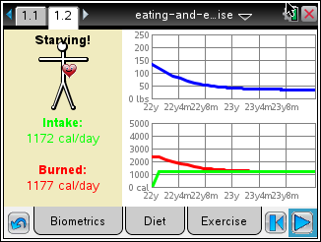 |  | 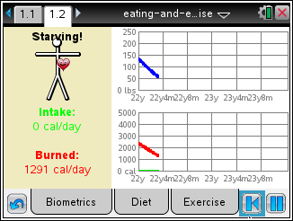
Q8. Are the food choices you made the second time better suited to your weight goals? If not how would you change them again?

Move back to Biometrics.
10. Now change exercise levels only and keep your diet the same.
11. Select the arrow . Then, select to replot the graph and observe changes in all the lines on the graph.

Q9. How did changing only exercise levels and not diet affect your weight over time?

Analysis Questions.  12. Now use the Internet to investigate other ways to help you achieve or maintain a healthy lifestyle. Try the website http://www.choosemyplate.gov/ to see a divided plate (pictured at the right), along with other information. This icon helps people visualize the percentages of the four food groups and dairy recommended by the government. |  | 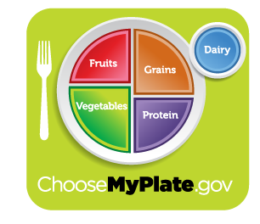
Q10. What do you notice about the percentage of space that each of the food groups takes up on the plate? Why do you think this is so?

Q11. About what percentage of the plate do vegetables take up? The percentage of fruits and vegetables combined?

Q12. Why do you think dairy is included as a separate icon?

13. Go to tab Exercise and look at the exercises listed. (Be sure to use the scroll bar to view all of them.)  Q13. List the group of exercises you think burn the most calories in the same amount of time? Which burn the least? Then view Internet sites such as http://www.nutristrategy.com/activitylist4.htm to check your estimate. |  | 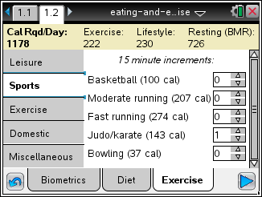
14. Now try improving food and exercise choices again based on what you learned from your research. Observe how your graphs change.
Q14. How did your research about food and exercise help you make better choices as you input improved diet and exercise choices?

