Open the TI-Nspire document Sum_or_Difference_of_Cubes.tns.  Some binomials can be described as the sum or difference of cubes. This activity looks at factoring these binomials. | 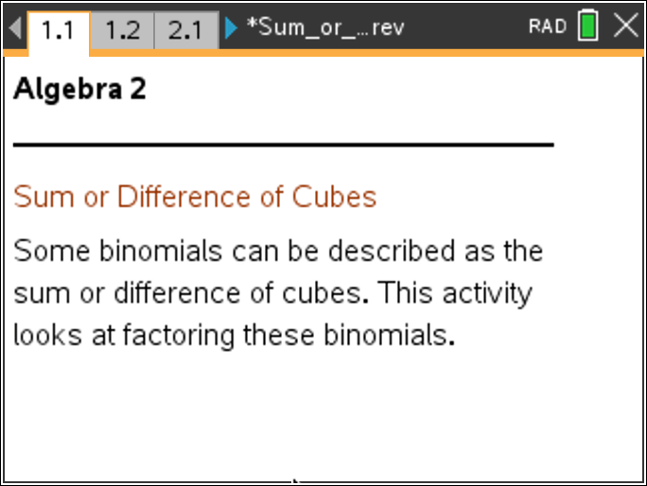

Move to page 1.2. | Press / ¢ and / ¡ to navigate through the lesson.
1. In order to factor binomials that are the sum or difference of cubes, you must be able find cube roots. Click on the Cube_root value to edit the cube root of the term shown. Press . to erase the current number and enter your answer. A message will tell you if your answer is correct. Click the slider (up or down arrows) to generate a new problem. How can you determine the sign of the cube root?

Move to page 2.1.

2. Click on the Choose slider to answer the question. Click on the New slider (up or down arrows) to generate a new question. Explain how to determine whether the binomial is the sum of cubes, difference of cubes, or neither.

product of cube roots
(cube root)²
cube root

The sum of cubes will factor according to the formula: .

(cube root)²
cube root

Notice the sign in the binomial factor is the same as the sign in the original binomial.
Note how the sign between the first two terms of the trinomial factor is the opposite.

Similarly, the difference of cubes factors as:.

Notice the sign in the binomial factor is the same as the sign in the original binomial.
Note how the sign between the first two terms of the trinomial factor is the opposite.

3. a. Is the pattern for factoring the difference of cubes the same as for the sum of cubes? Explain.

b. Use the Distributive Property to justify that both formulas result in the sum or difference of cubes.

Move to page 3.1.

4. Click on the slider (up or down arrows) to generate new graphs. The graphs of the linear and quadratic factors are dotted. The graph of the product (the sum or difference of cubes) is thick. What connection does the graph of the sum or difference of cubes have with its linear factor?

5. Will the sum or difference of cubes function always cross the x-axis? How do you know?

6. a. How does the graph of the quadratic factor of the sum or difference of cubes show that it is not factorable?

b. Prove algebraically that the trinomial factors shown above and are not factorable.

Move to page 4.1.

Enter the binomial factor, in quotes, into Column B in the spreadsheet. Press · and a check mark will indicate when your answer is correct. It automatically moves to the next entry.
Move to page 5.1.

Enter the trinomial factor, in quotes, into Column B in the spreadsheet. Press · and a check mark will indicate when your answer is correct. It automatically moves to the next entry.

7. Andrew correctly finds that the first factor of the sum of cubes is . What is the second factor? What is the expanded form?

8. Alex correctly finds that the second factor of the sum of cubes is . What is the first factor? What is the expanded form?

9. Sometimes the sum or difference of cubes can be factored further.
a. Can be considered the difference of cubes? Explain and factor accordingly.

b. Can be considered the difference of squares? Explain and factor accordingly.

- Explain the different factored forms for part 9a and 9b.

